**Name : SHAIK BURAHAN**

**Email :** [**228x1a05g**9**@khitguntur.ac.in**](mailto:228x1a05g9@khitguntur.ac.in)

**College : Kallam Haranadhareddy Institute of Technology Branch : CSE**

**Project Name : TravelGo: A Cloud-Powered Real-Time Travel Booking Platform Using AWS**

TravelGo: A Cloud-Powered Real-Time Travel Booking Platform Using AWS

**Project Description:**

**TravelGo** is a full-stack, cloud-based travel booking platform designed to simplify the process of reserving buses, trains, flights, and hotels through a unified interface. Built using Flask as the backend framework, the application is deployed on Amazon EC2 and leverages DynamoDB for efficient storage of user data and bookings. TravelGo allows users to register, log in, search for transportation and accommodation options, and book their travel with ease. Once a booking is confirmed or cancelled, users receive real-time email notifications powered by AWS Simple Notification Service (SNS), keeping them informed throughout their journey.

The platform’s user-friendly interface supports dynamic seat selection for buses, hotel filtering based on preferences such as luxury or budget, and provides booking summaries along with centralized cancellation management. By combining cloud scalability, responsive design, and secure session handling, TravelGo delivers a seamless and real-time travel planning experience for users.

**Scenario 1: Hassle-Free Multi-Mode Travel Booking Experience**

**TravelGo** offers users a unified platform to search and book buses, trains, flights, and hotels all in one place. For instance, a user planning a trip from Hyderabad to Bangalore can log in, select their preferred mode of transport, choose from available options, and proceed to booking. Flask manages the backend operations such as retrieving travel listings and processing user input in real-time. Hosted on AWS EC2, the platform remains responsive even during high-traffic hours like weekends or holiday seasons, allowing multiple

users to browse and book without delay.

**Scenario 2: Real-Time Booking Confirmation with AWS SNS**

Once a booking is made—whether it’s a train ticket or a hotel stay—TravelGo uses AWS SNS to instantly notify the user. For example, after a student books a hotel in Chennai, SNS sends a real-time email notification confirming the booking with all the relevant details. This notification is triggered from the

Flask backend after the booking is successfully recorded in DynamoDB. Additionally, SNS can alert admin or service providers, ensuring transparency and real-time updates on every transaction.

**Scenario 3: Dynamic Dashboard with Personal Travel History**

TravelGo features a dynamic user dashboard that displays all past and upcoming bookings for the logged-in user. For example, a user who has booked a flight and a hotel can view these bookings categorized by type, along with dates, price, and cancellation options. Flask fetches this data from AWS DynamoDB, which persistently stores all user bookings. The dashboard UI, powered by responsive HTML/CSS and Flask templates, ensures users can review or manage bookings anytime, from any device, with real-time updates and quick cancellation workflows supported.

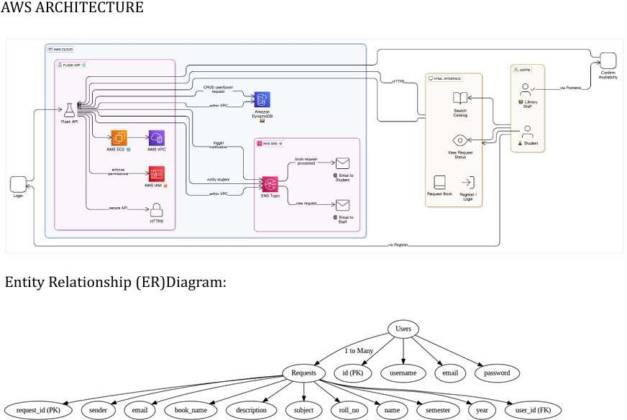

Project WorkFlow:

1. AWS troven access Setup and Login
   1. : Set up an troven access
   2. : Open the AWS Management Console
2. DynamoDB Database Creation and Setup
   1. : Create a DynamoDB Table.
   2. : Configure Attributes for User Data and Booking Requests.
3. SNS Notification Setup Activity
   1. : Create SNS topics.
   2. : Subscribe users and library staff to SNS email notifications.
4. Backend Development and Application Setup 4.1:Develop the Backend Using Flask.

4.2: Integrate AWS Services Using boto3.

1. IAM Role Setup
   1. : Create IAM Role
   2. : Attach Policies
2. EC2 Instance Setup Activity
   1. : Launch an EC2 instance to host the Flask application.
   2. : Configure security groups for HTTP, and SSH access.
3. Deployment on EC2 Activity
   1. :Upload Flask Files Activity
   2. : Run the Flask App
4. Testing and Deployment Activity
   1. : Conduct functional testing to verify user registration, login, bookings, and notifications.
5. **AWS troven access Setup and Login**
   * Activity 1.1: Set up an troven access

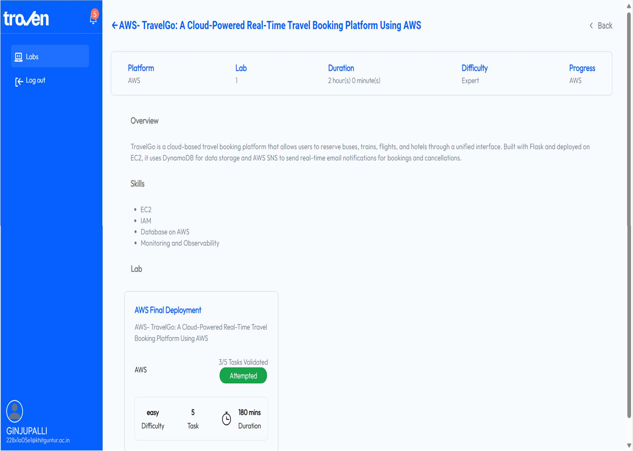

* Activity 1.2: Open the AWS Management Console

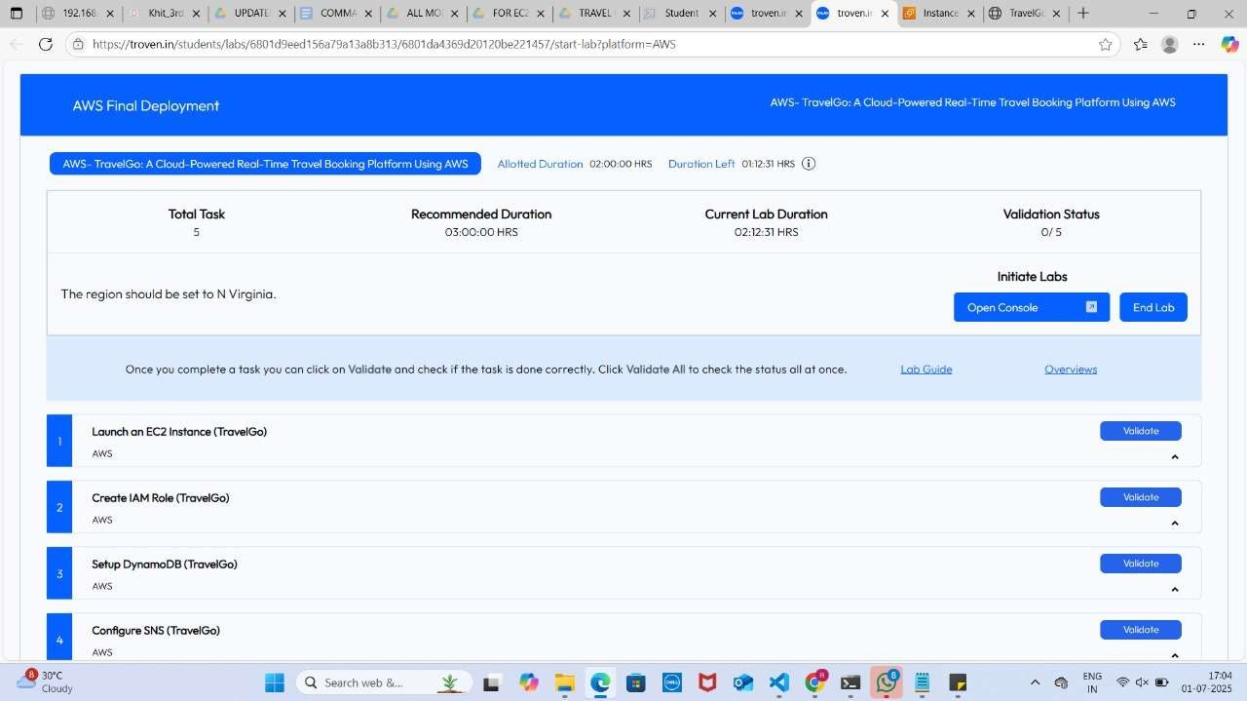

1. **DynamoDB Database Creation and Setup**

Activity 2.1: Create a DynamoDB Table

To create a DynamoDB table, go to the AWS Management Console, navigate to **DynamoDB**, and click **"Create table."** Specify a **table name** and define a **primary key** (e.g., Email as Partition Key). Choose additional settings like **read/write capacity mode** (on-demand or provisioned) and click **"Create."** Your table will be ready in seconds for data operations.

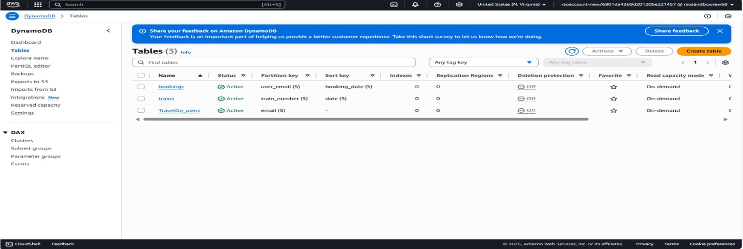

Activity 2.2: Configure Attributes for User Data and Booking Requests

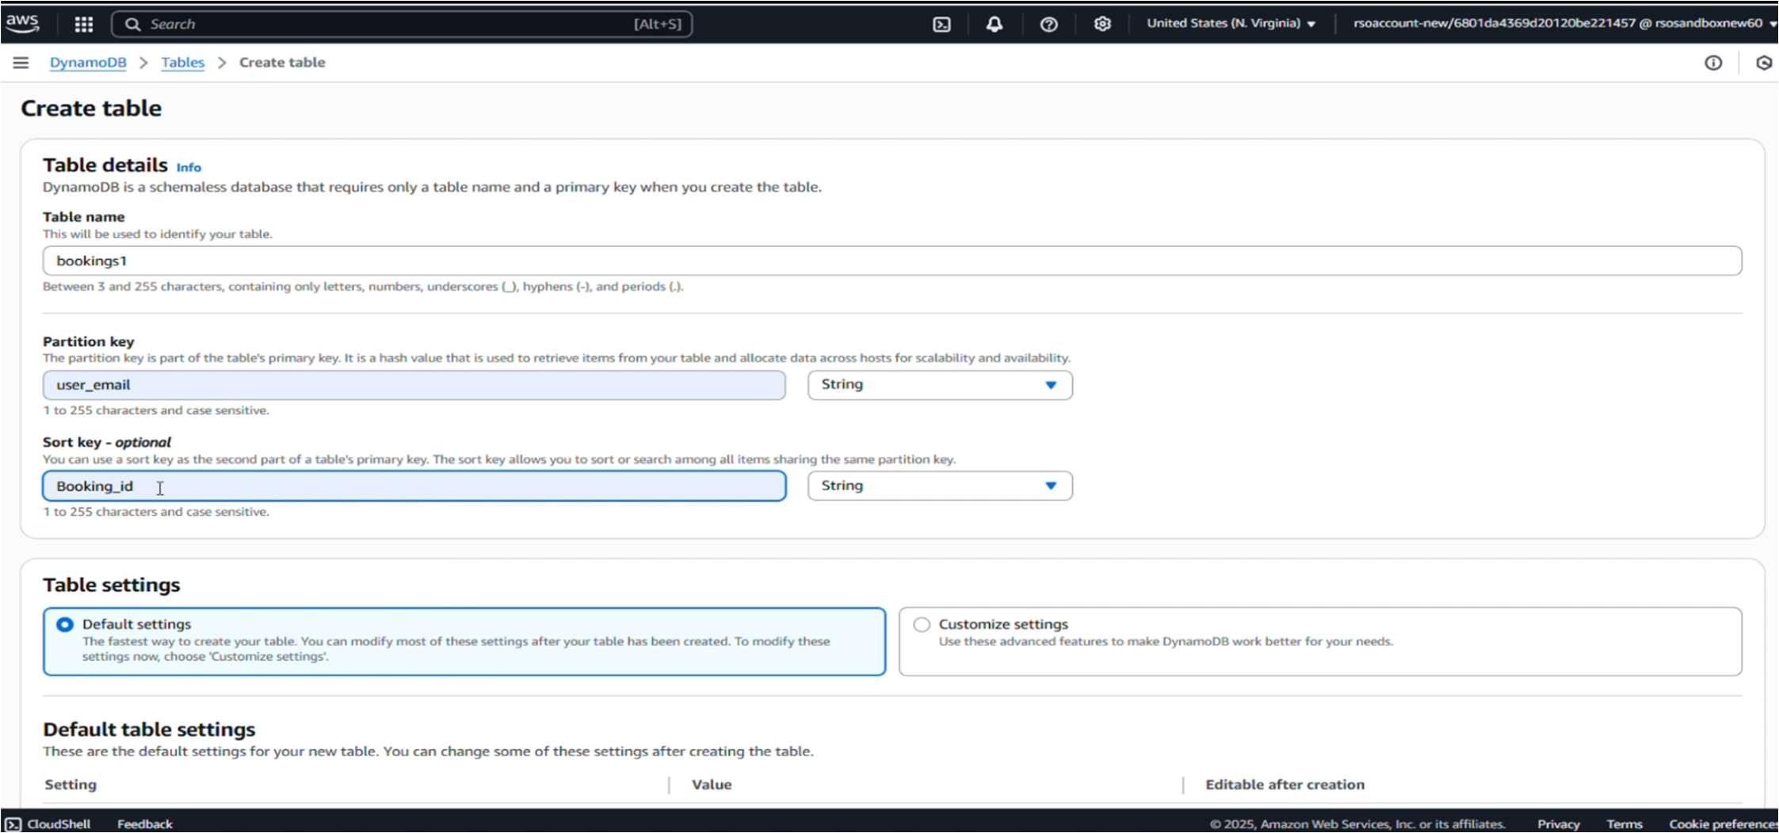

1. **SNS Notification Setup**

For **SNS Notification Setup**, go to the AWS Console and open the **Simple Notification Service (SNS)** dashboard. Click **“Create topic”**, choose the **Standard** type, and name your topic. After creating it, copy the **Topic ARN**. Then, **subscribe email addresses** (students/admins) to the topic and confirm the subscription via email.

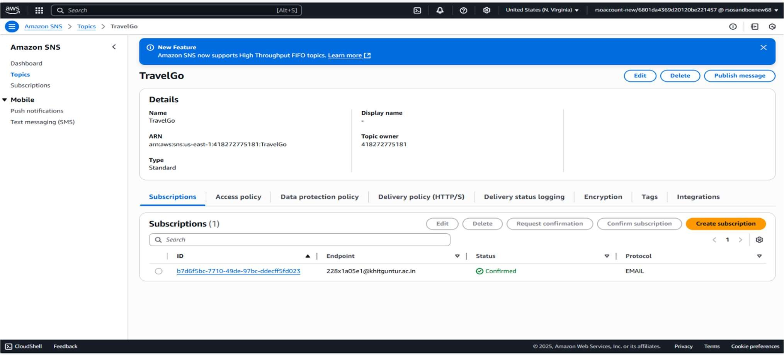Activity 3.1: Create SNS topics.

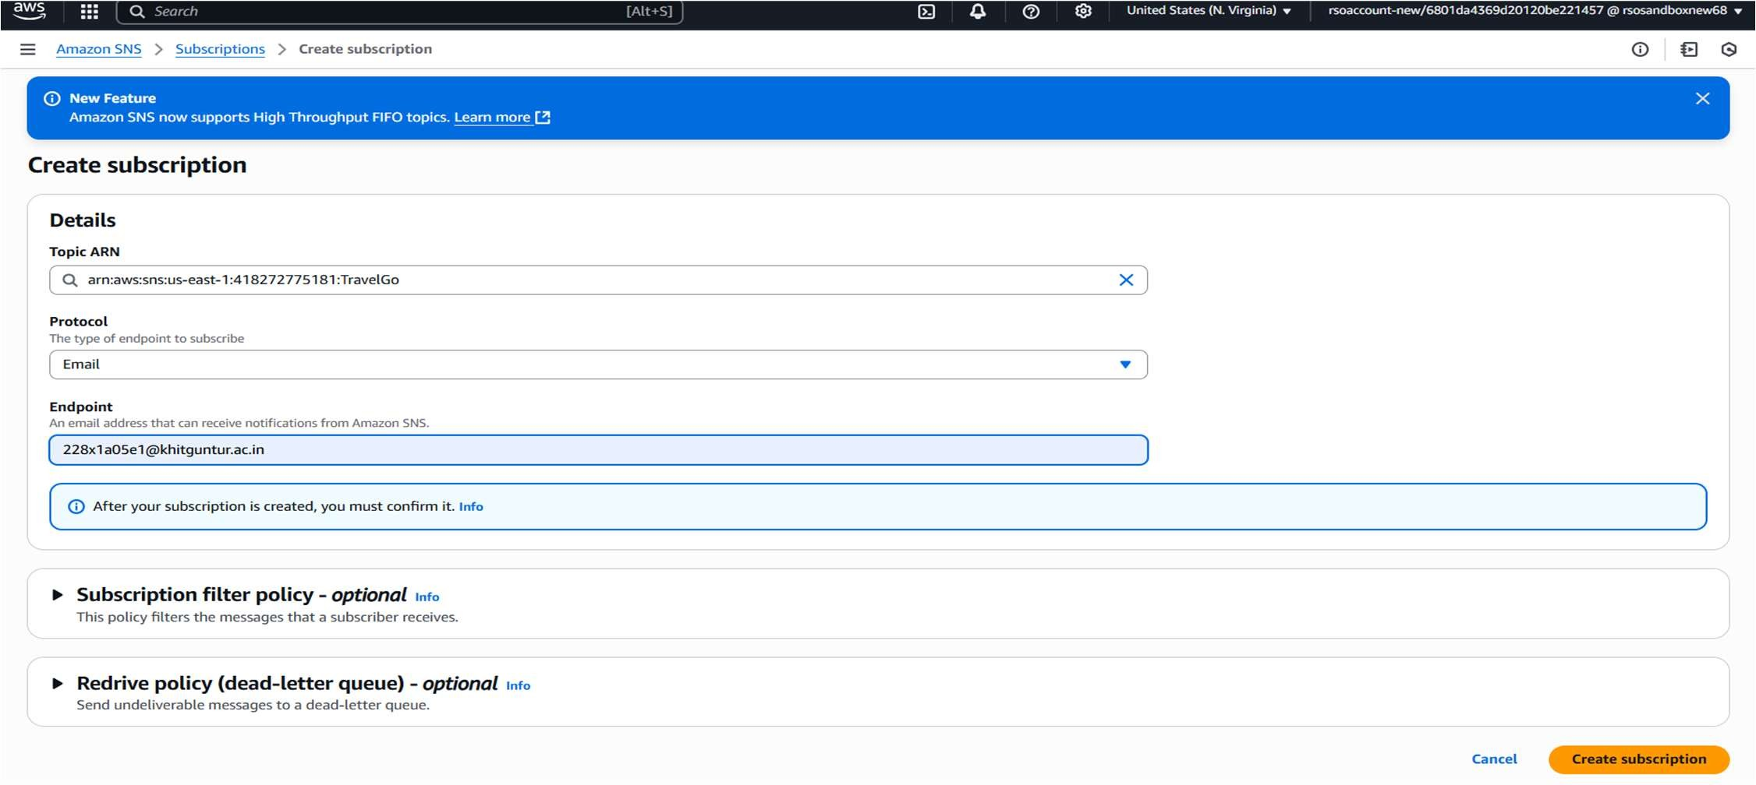Activity 3.2: Subscribe users to SNS email notifications

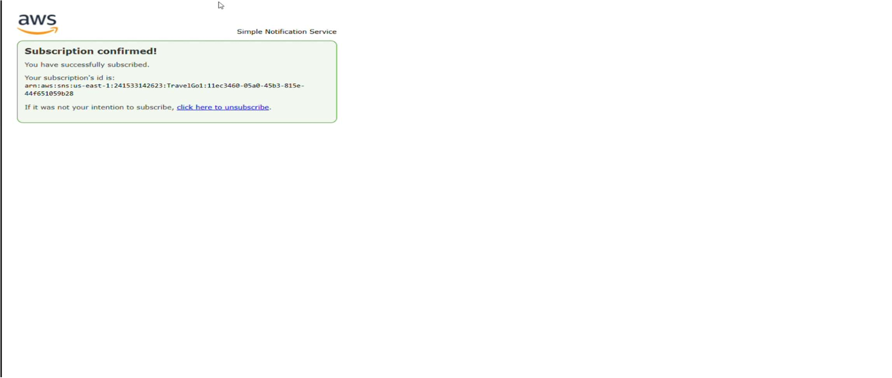

1. **Backend Development and Application Setup**

In the Backend Development and Application Setup, use Flask to build the web application and integrate AWS services via the boto3 library. Set up routes for user registration, login, book requests, and page navigation. Connect to DynamoDB to store user and request data, and configure AWS SNS to send notifications. Organize files into app.py, templates/, and static/ folders for a clean project structure

Activity 4.1:Develop the Backend Using Flask.

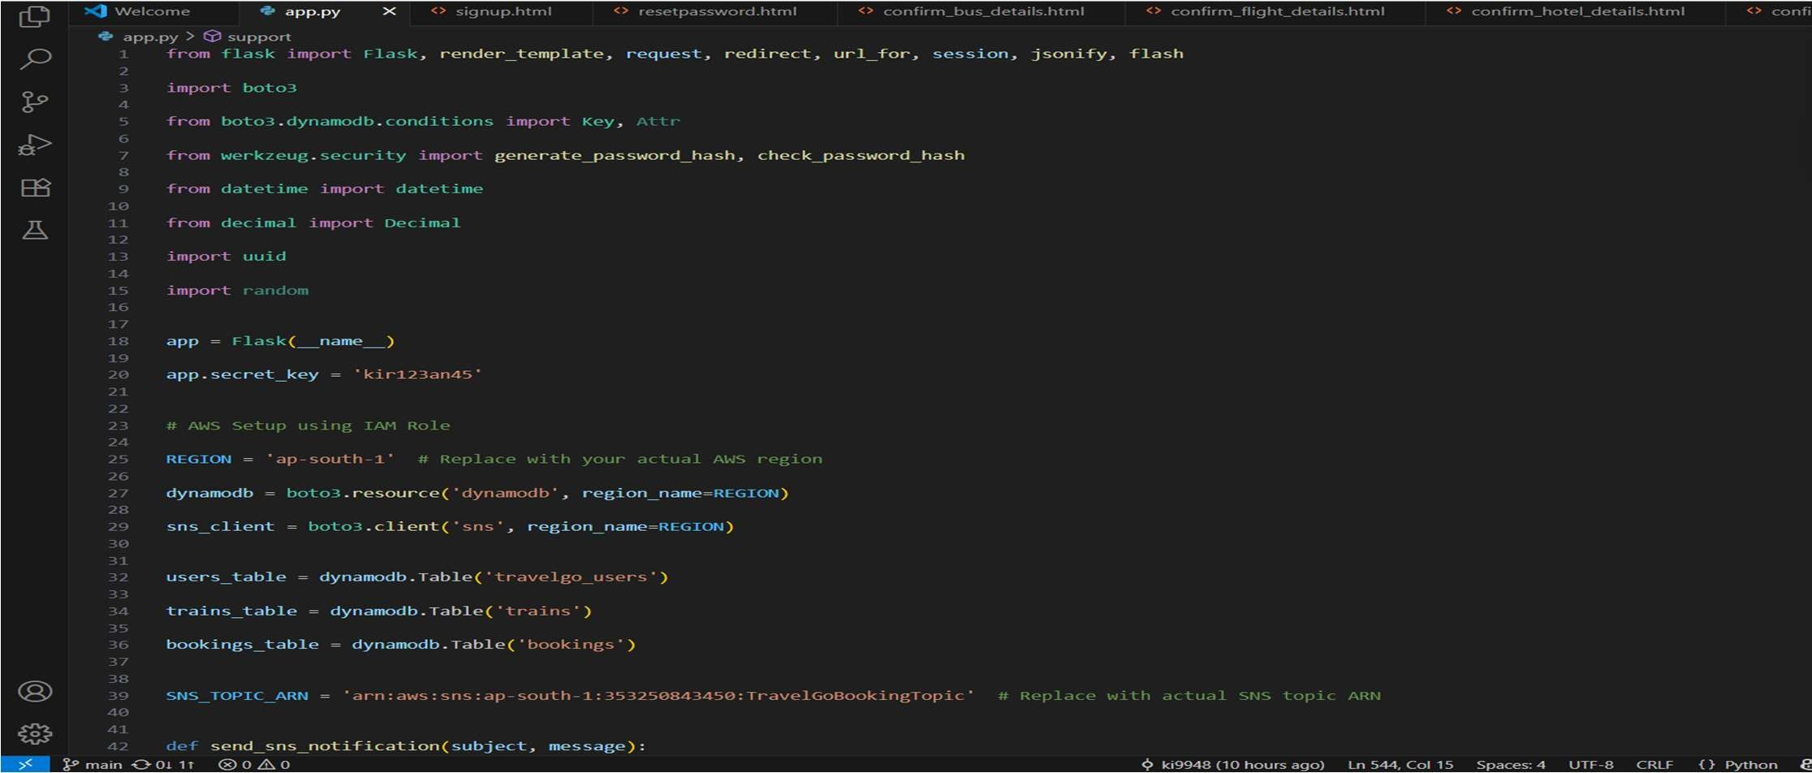

Activity 4.2: Integrate AWS Services Using boto3

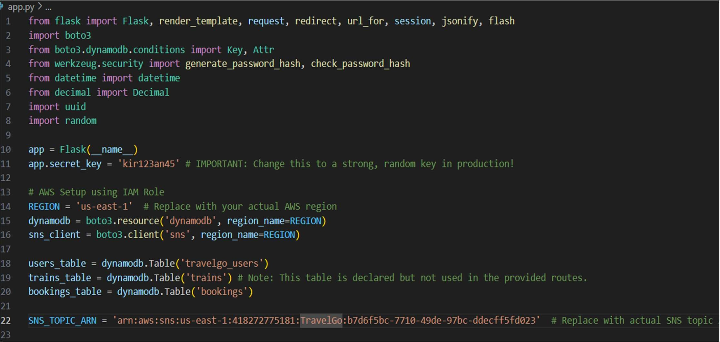

**Code for SNS**

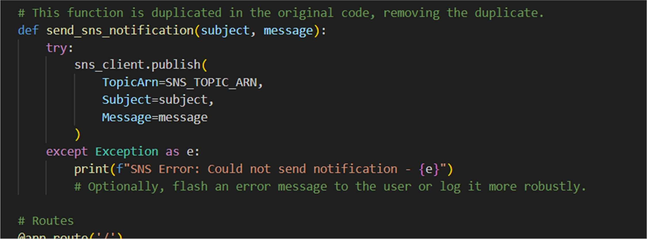

**CODE for Register**

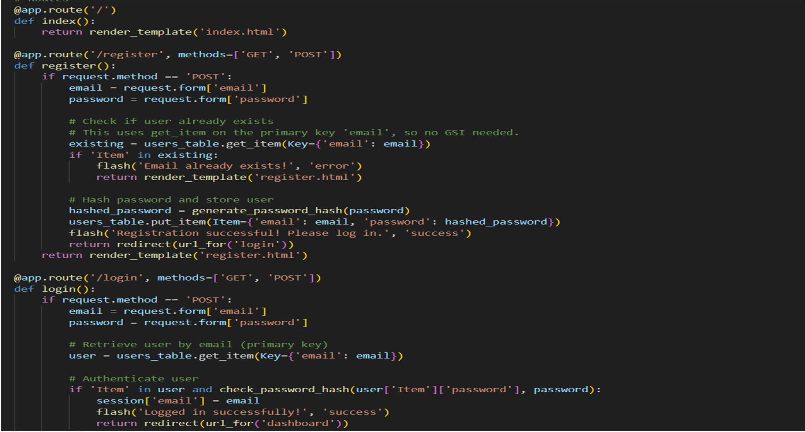

**Code for Dashboard**

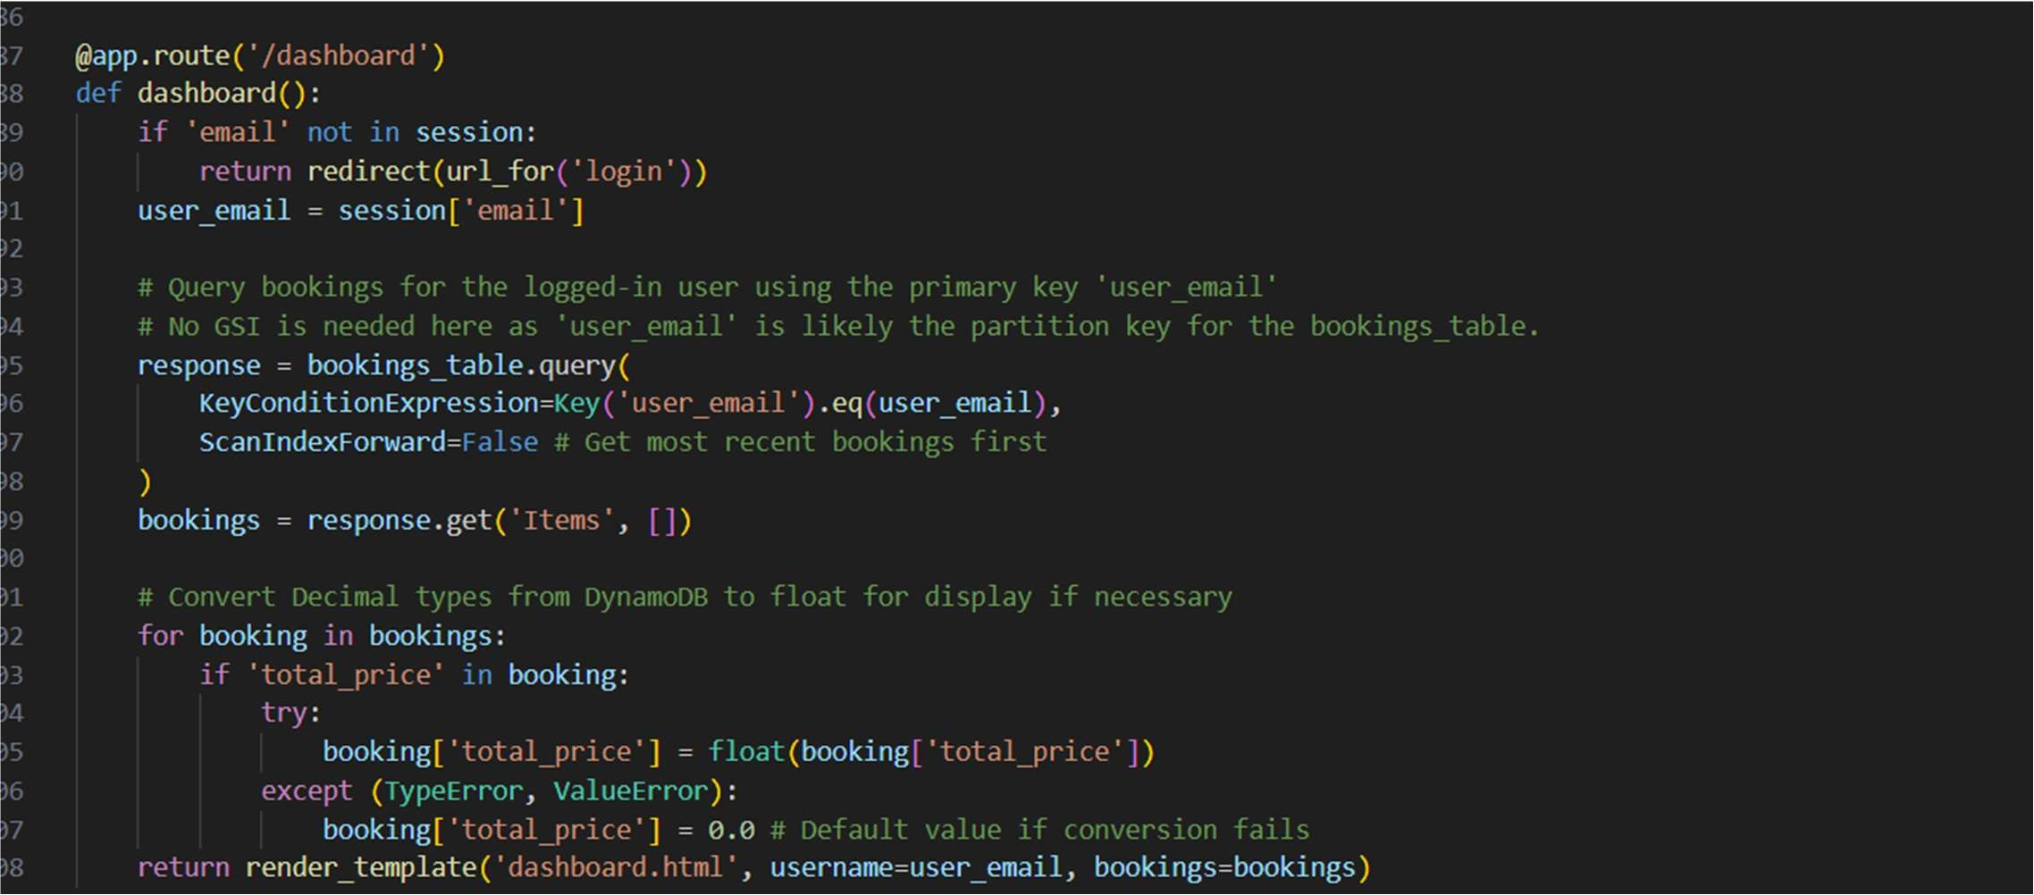

**Code for Cancel booking**

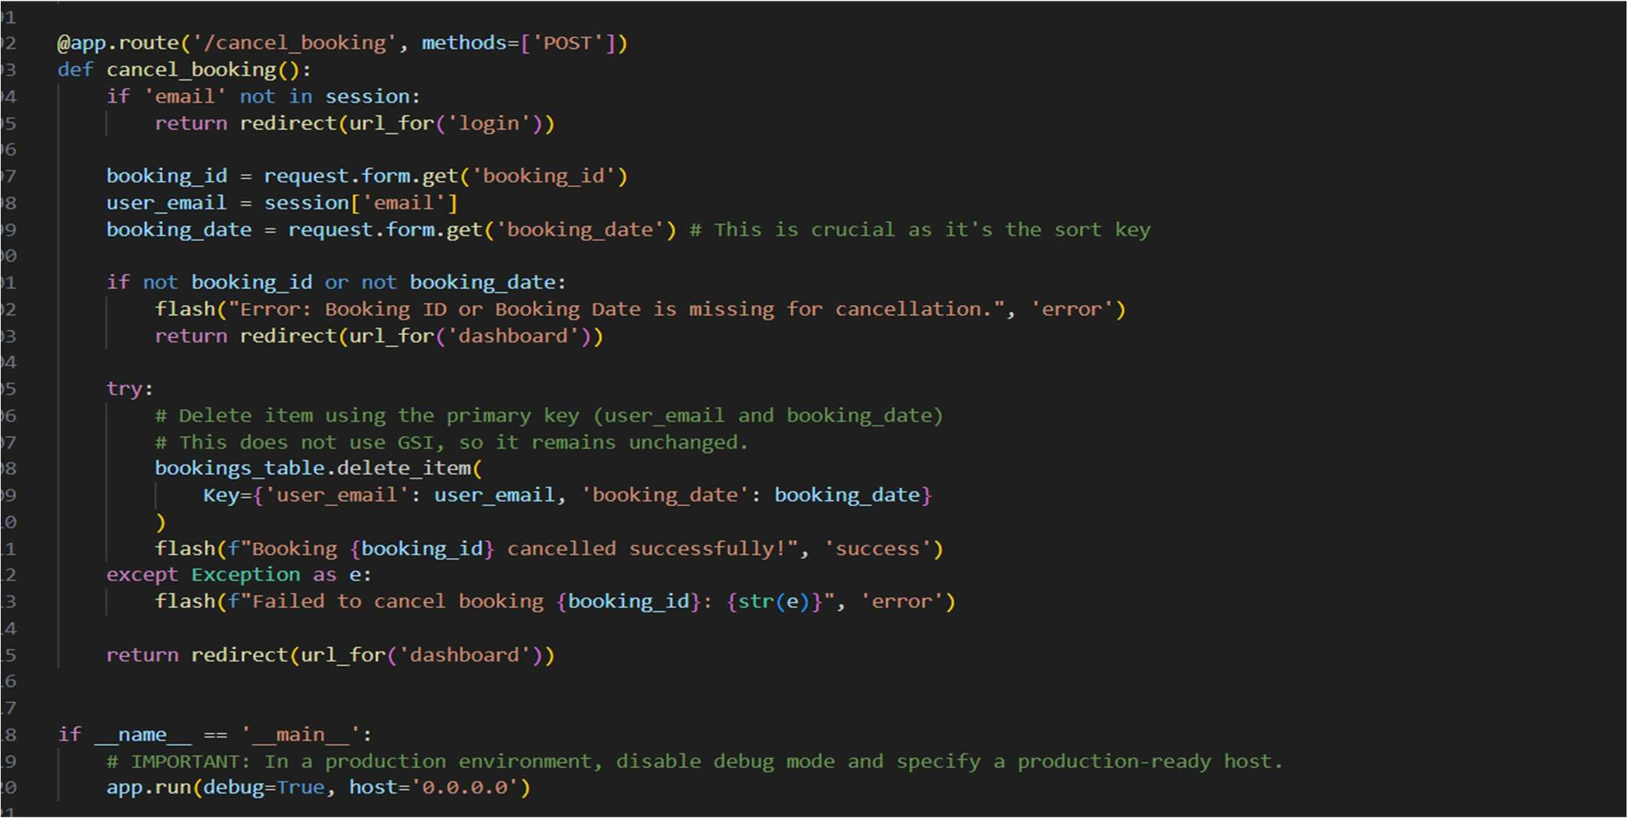

1. **IAM Role Setup**

For IAM Role Setup, go to the AWS Console and create a new IAM Role for your EC2 instance.

Attach AmazonDynamoDBFullAccess and AmazonSNSFullAccess policies to allow interaction with DynamoDB and SNS. Assign this role to your EC2 instance during or after launch. This ensures secure and authorized access to AWS resources from your Flask backend.

Activity 5.1: Create IAM Role Activity 5.2: Attach Policies

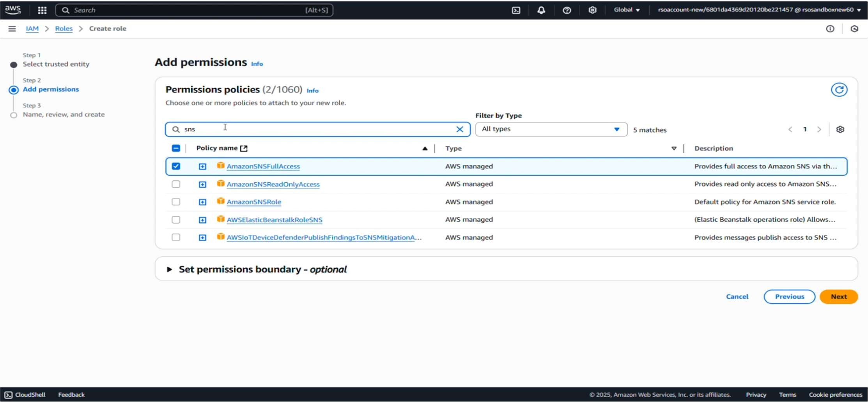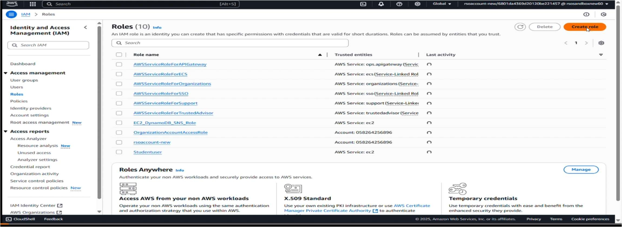

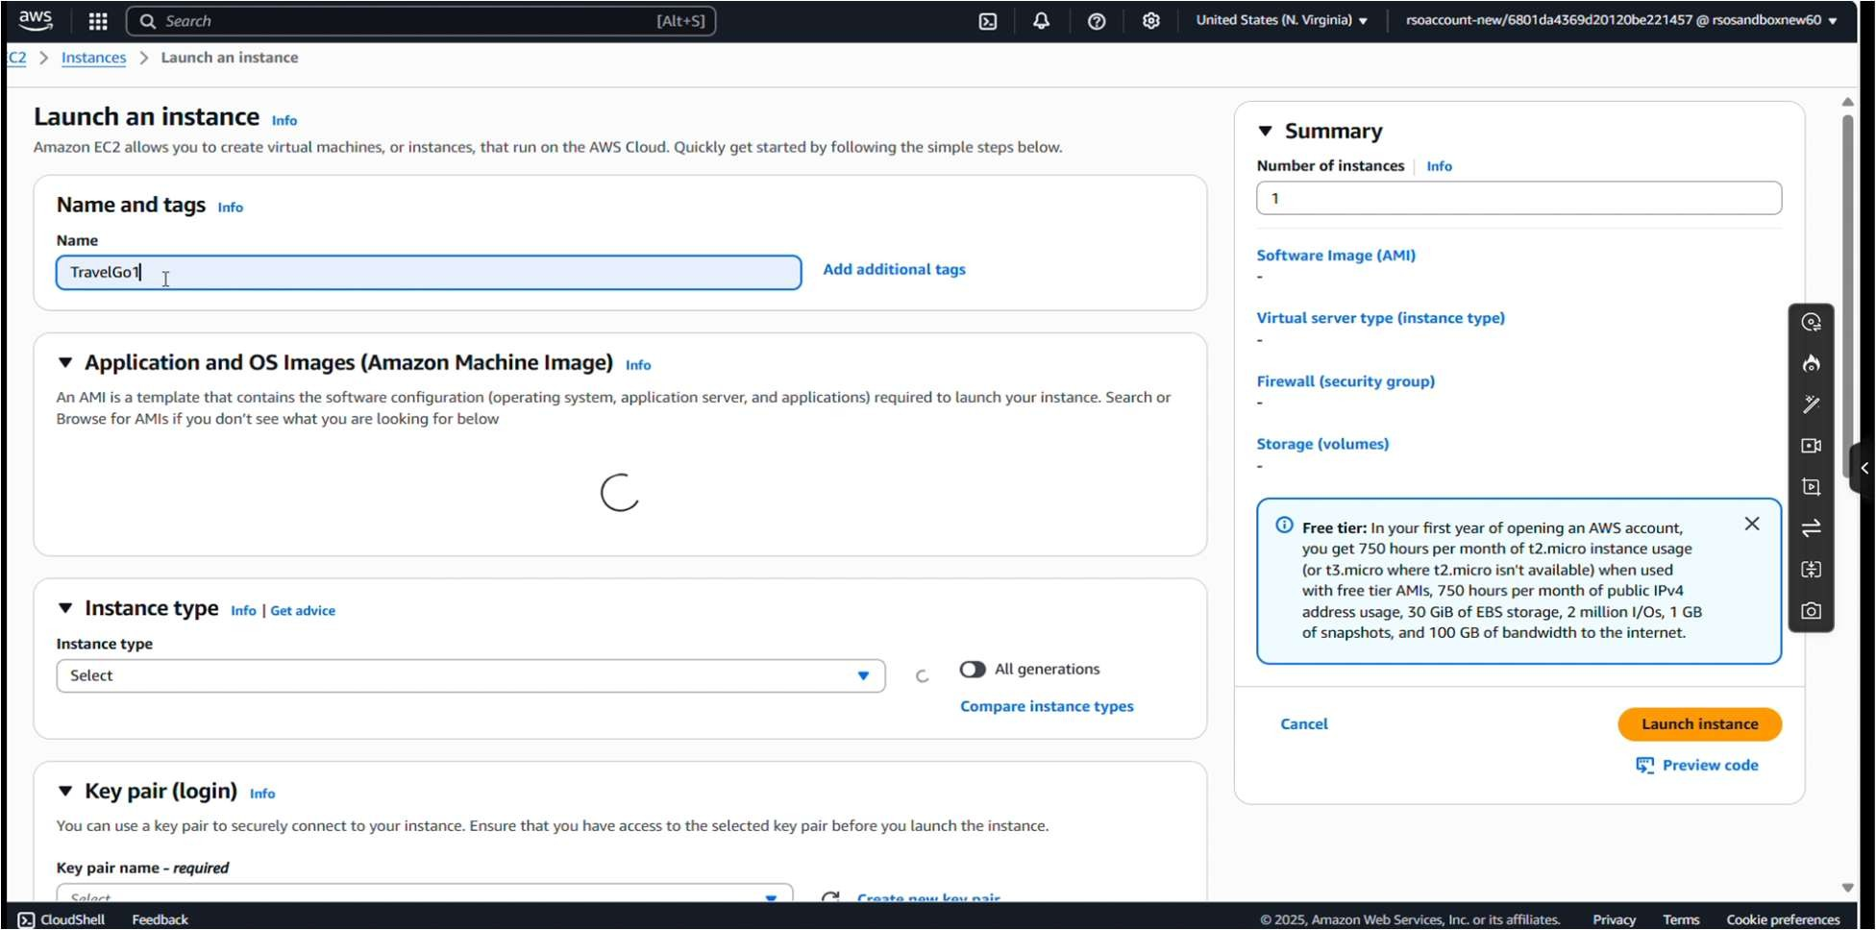

create a key pair:

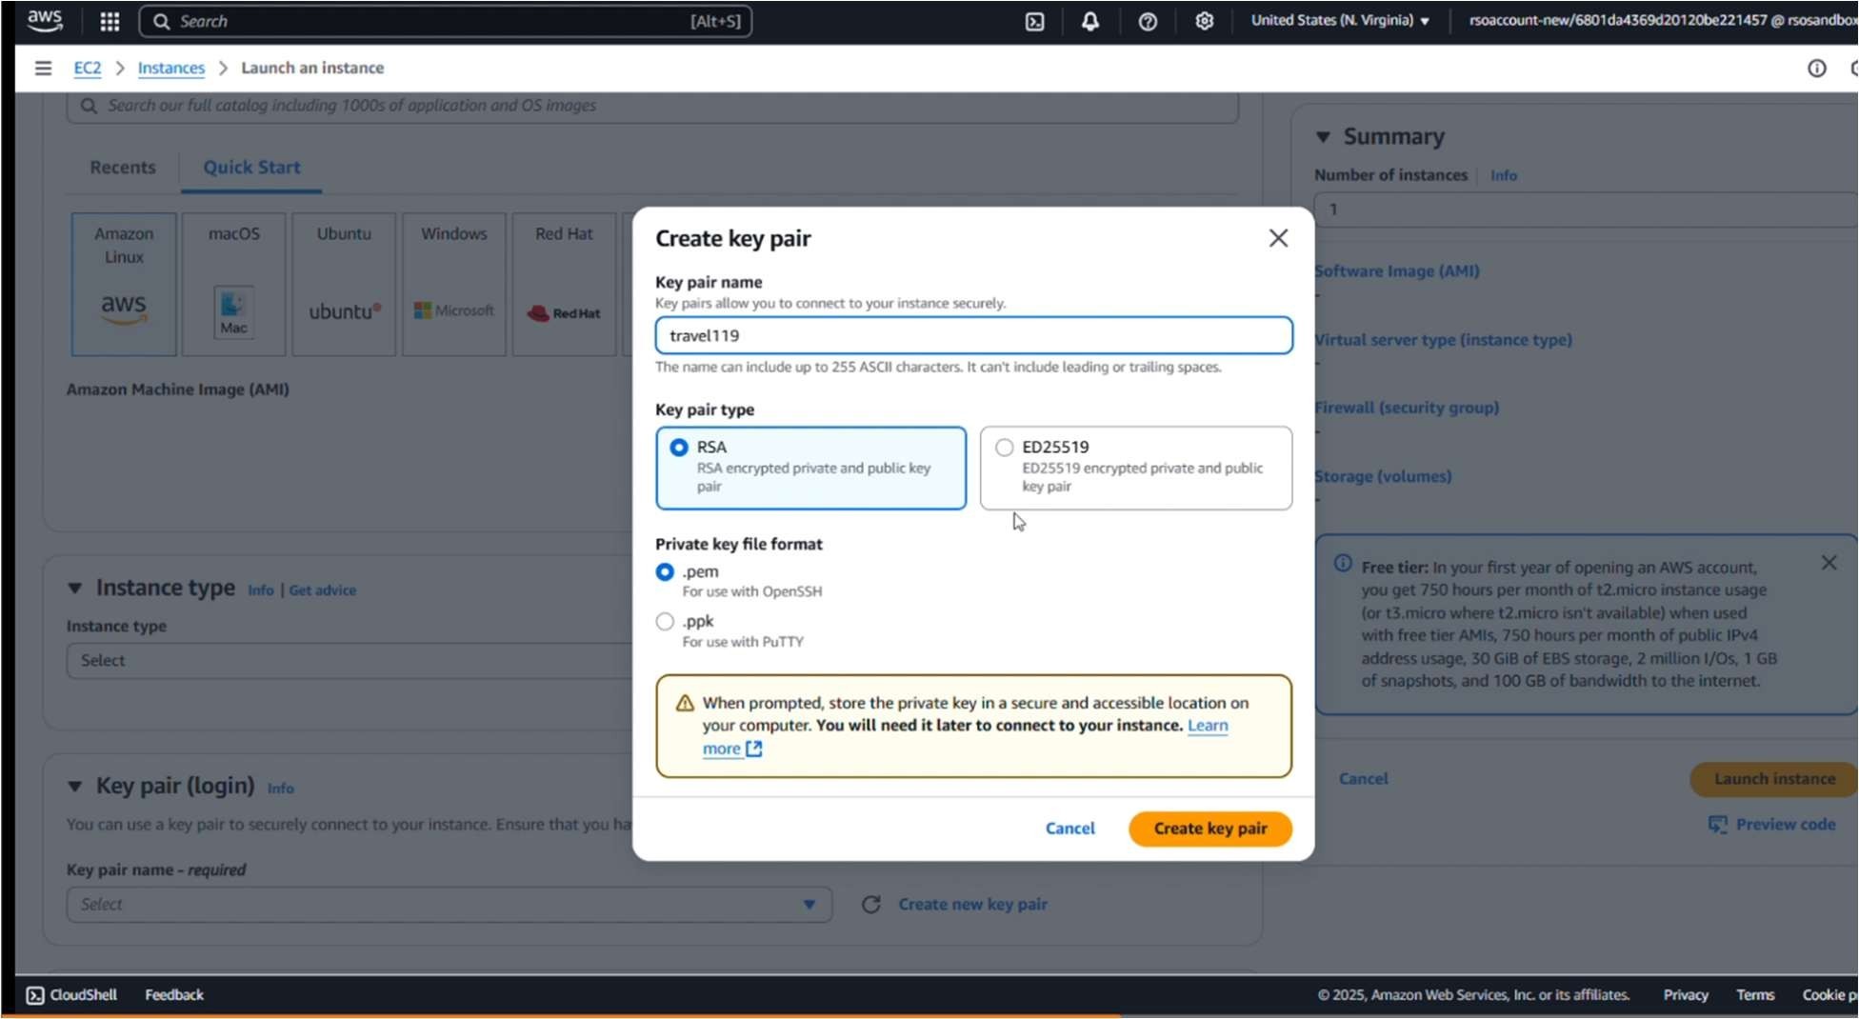

Edit of Security group:

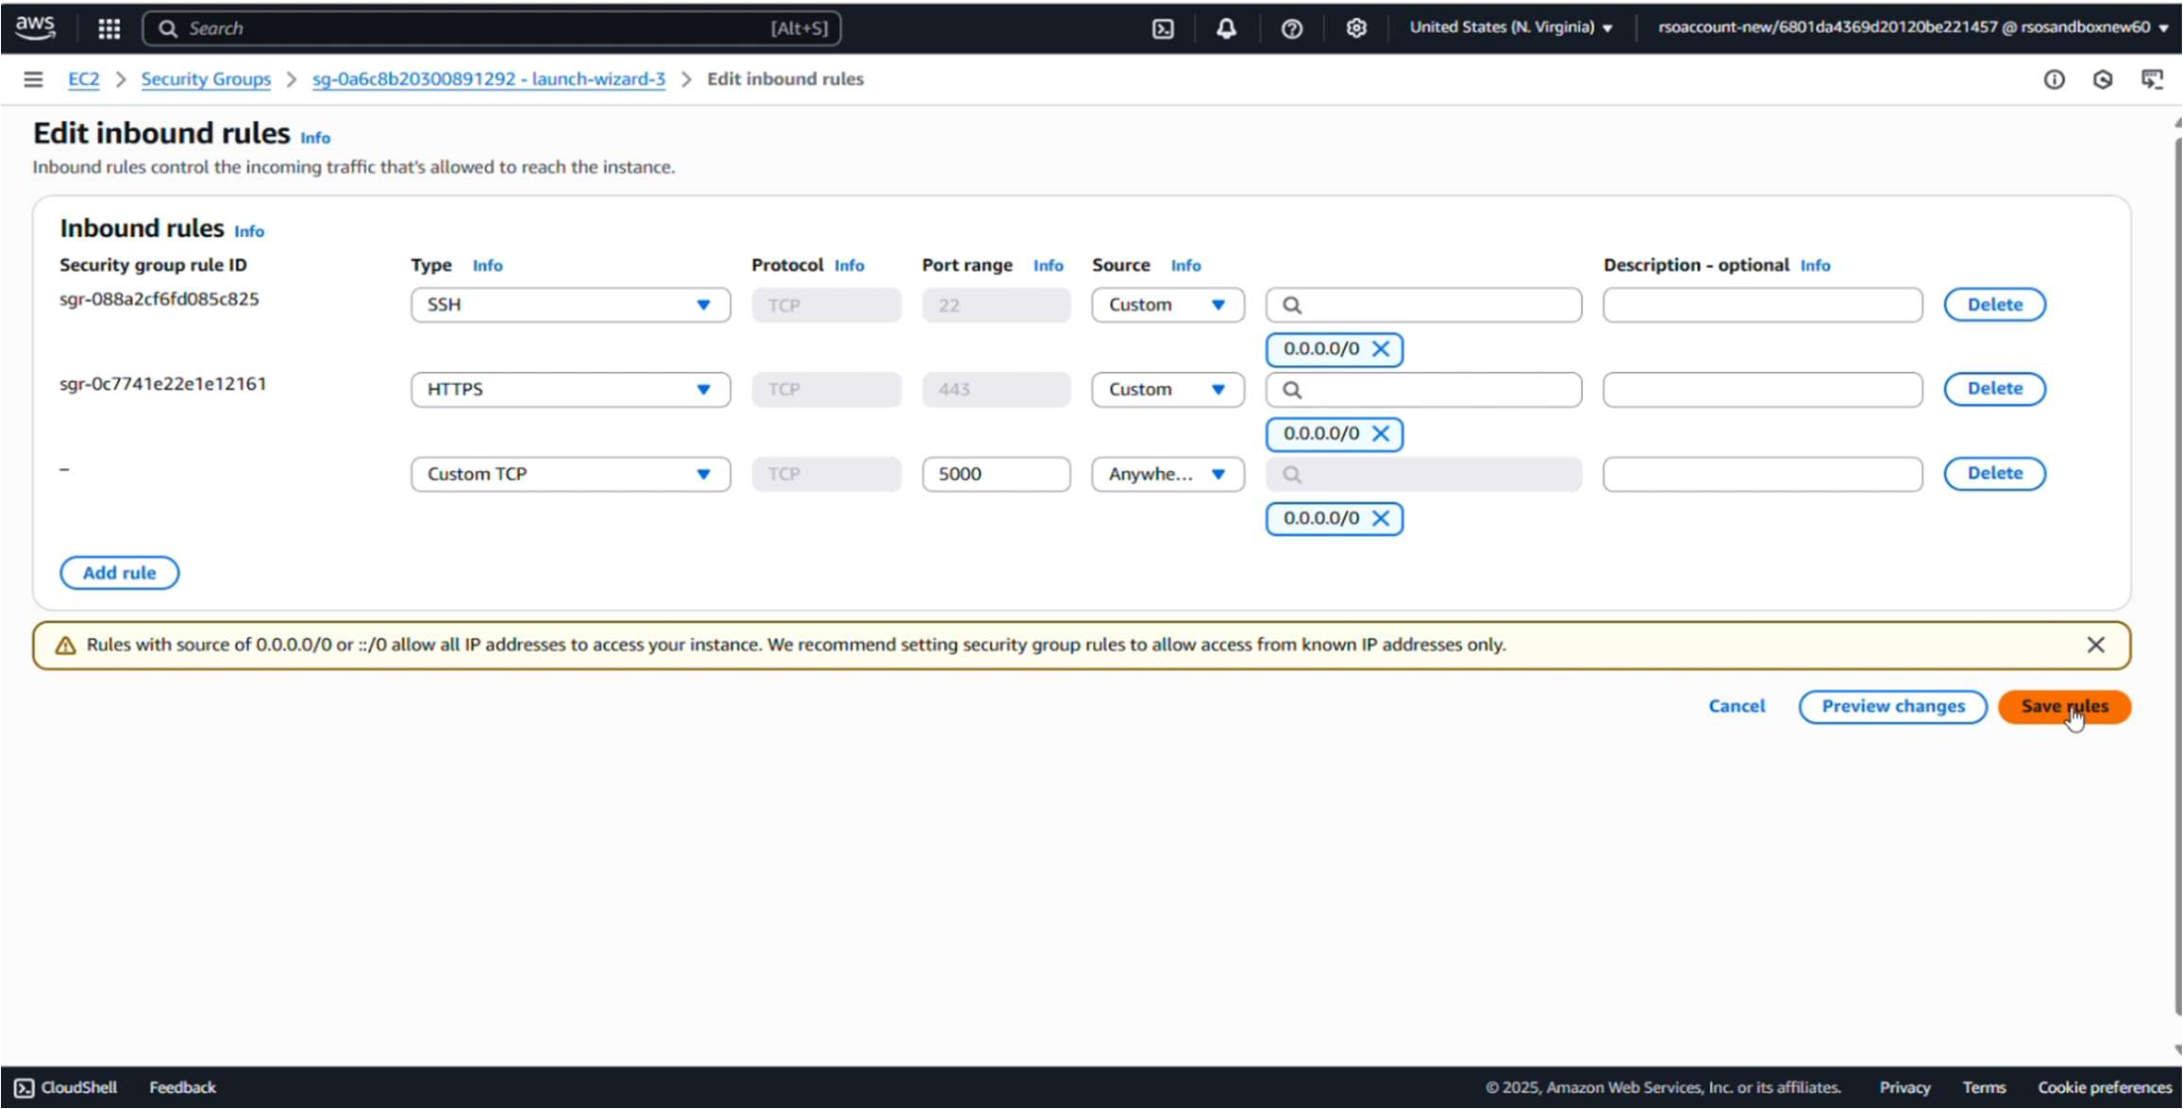

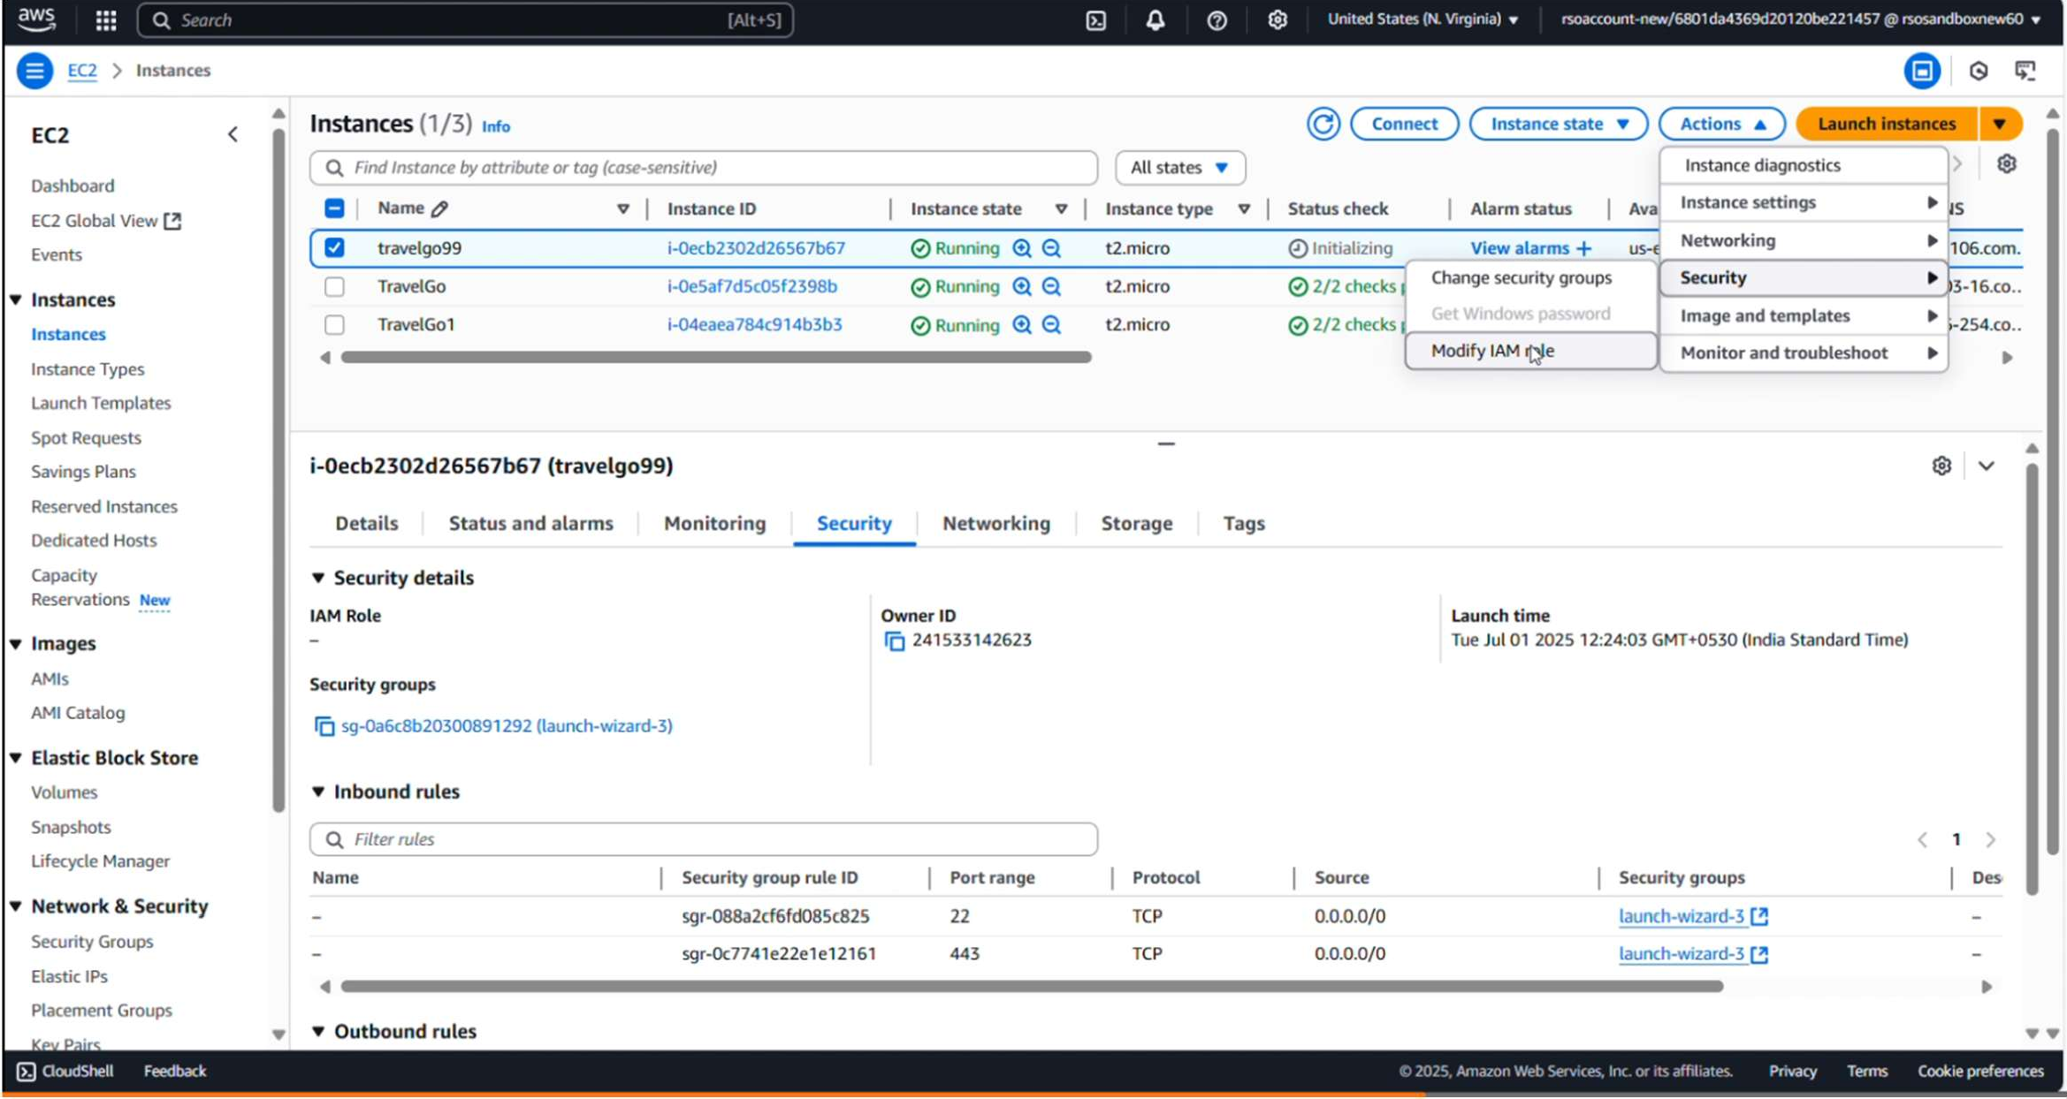

EC2 Connet:

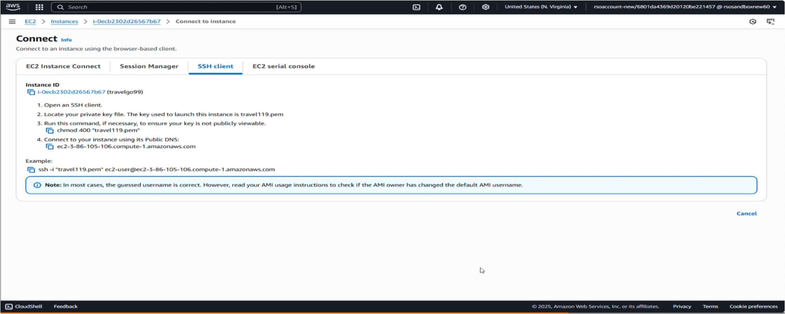

**Milestone 7: Deployment on EC2**

**Activity 7.1: Install Software on the EC2 Instance**

Install Python3, Flask, and Git: On Amazon Linux 2:

sudo yum update -y sudo yum install python3

git sudo pip3 install flask boto3 Verify Installations:

flask --version git --version

**Activity 7.2:Clone Your Flask Project from GitHub**

**Clone your project repository from GitHub into the EC2 instance using Git.**

Run: ‘git clone [https://github.com/BURAHAN12/TRAVELGO.git](https://example.com/)'

Note: change your-github-username and your-repository-name with your credentials here: ‘git clone https://github.com/AlekhyaPenubakula/InstantLibrary.git’

* This will download your project to the EC2 instance.

**To navigate to the project directory, run the following command:**

cd InstantLibrary

**Once inside the project directory, configure and run the Flask application by executing the following command with elevated privileges:**

**Run the Flask Application**

sudo flask run --host=0.0.0.0 --port=80

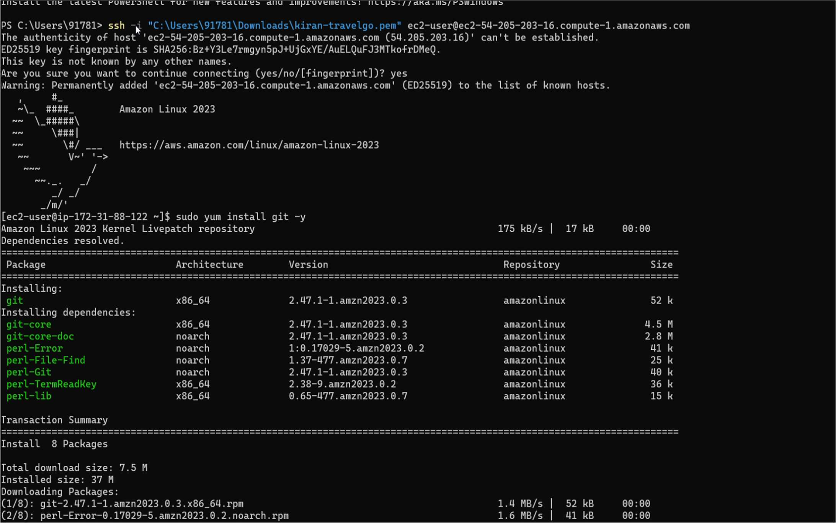

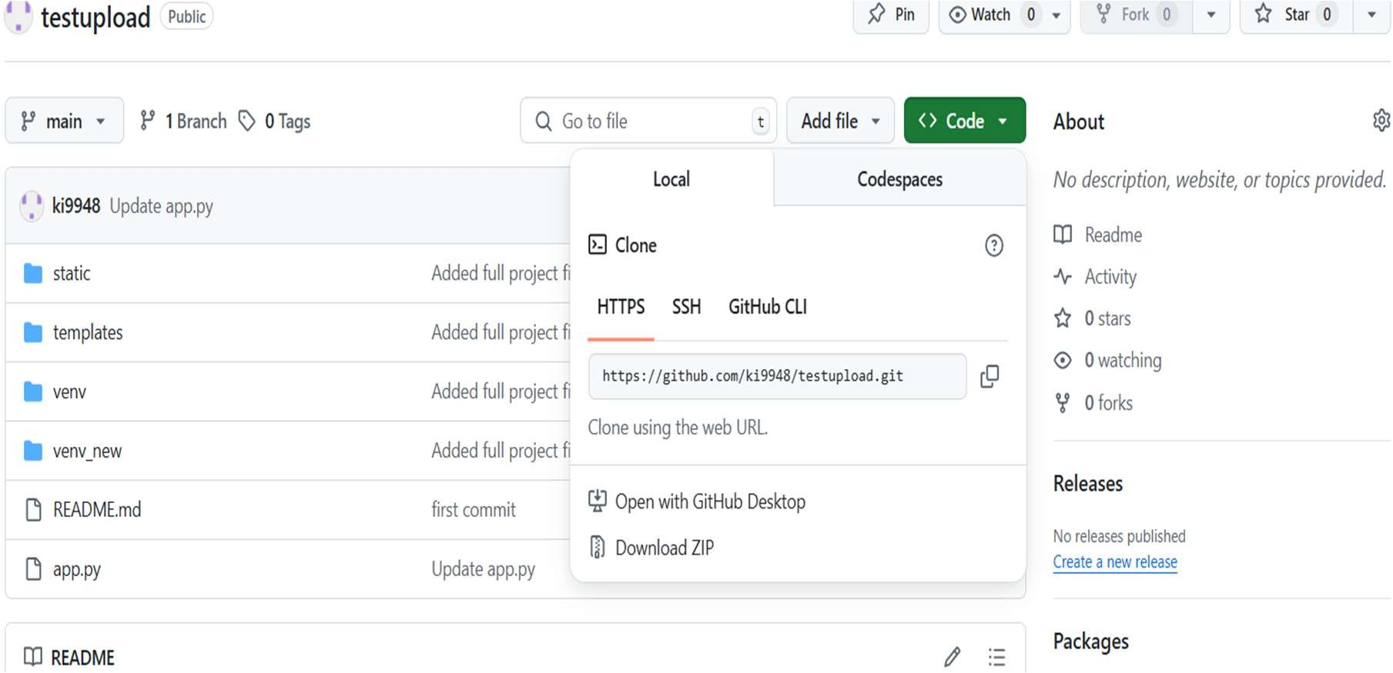

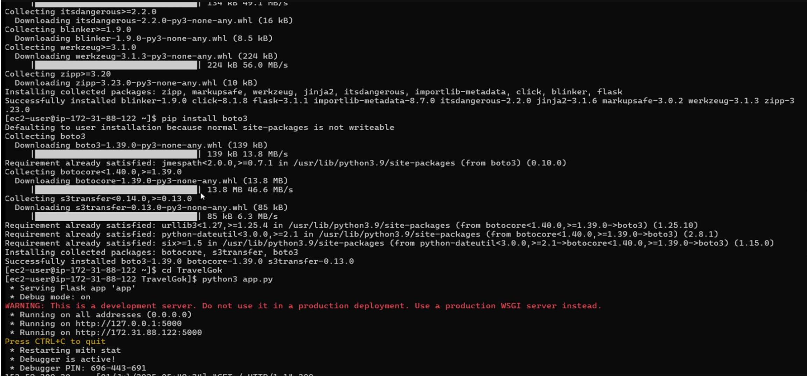

Index page:

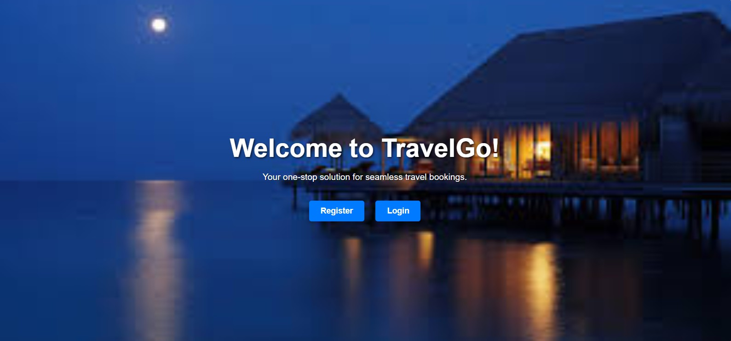

Register page:

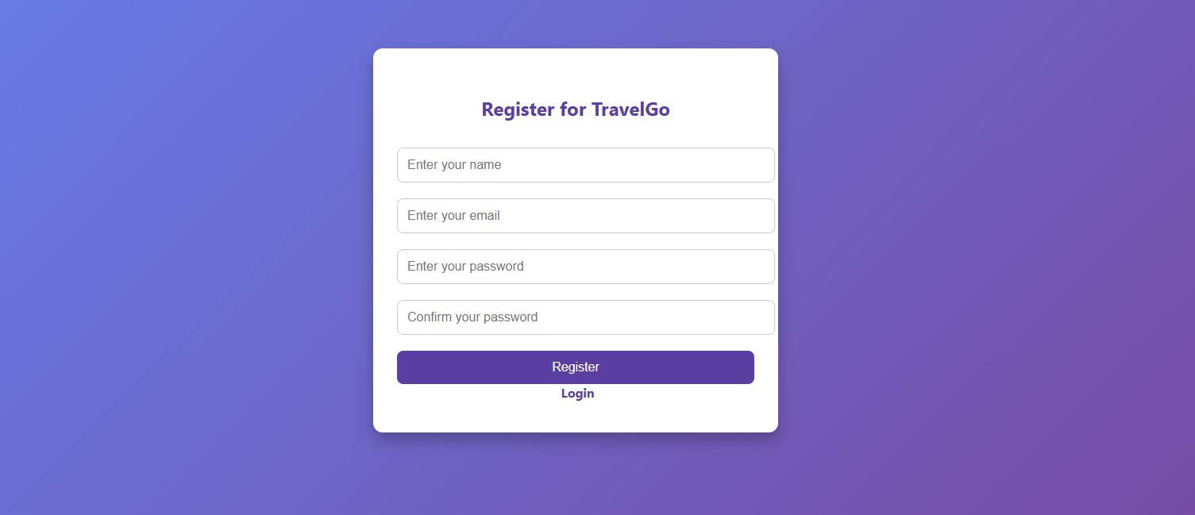

Login page:

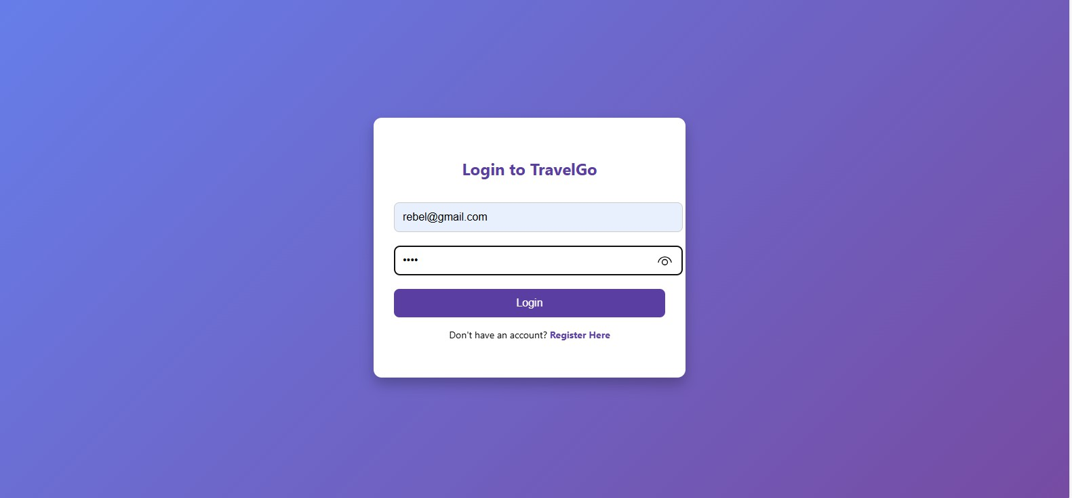

Home Code:

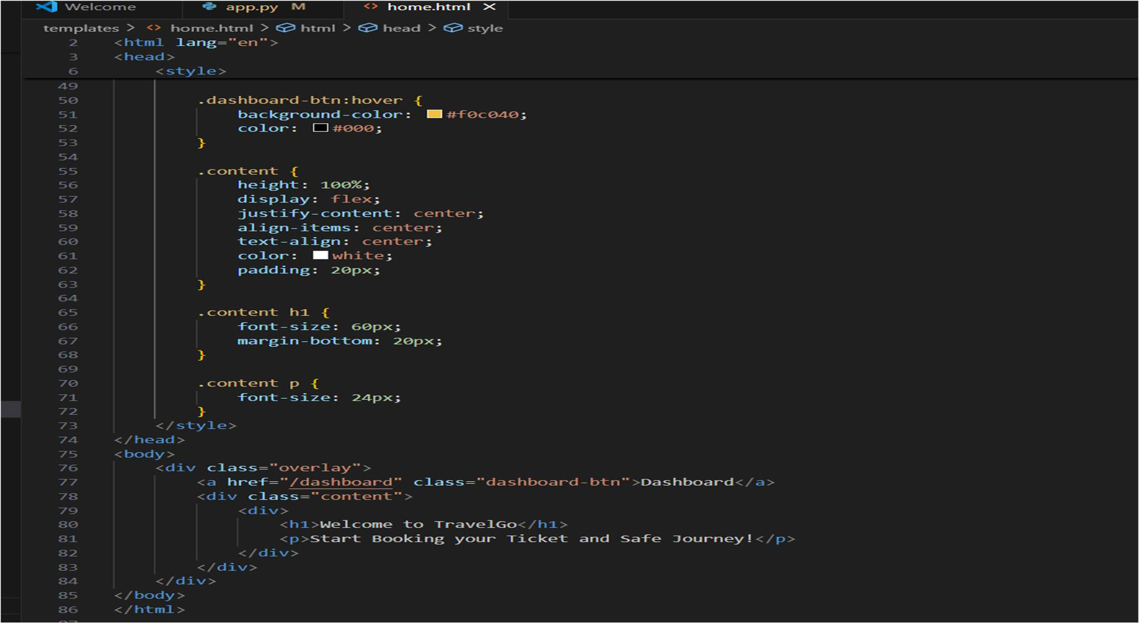

Home page:



Dashboard code:

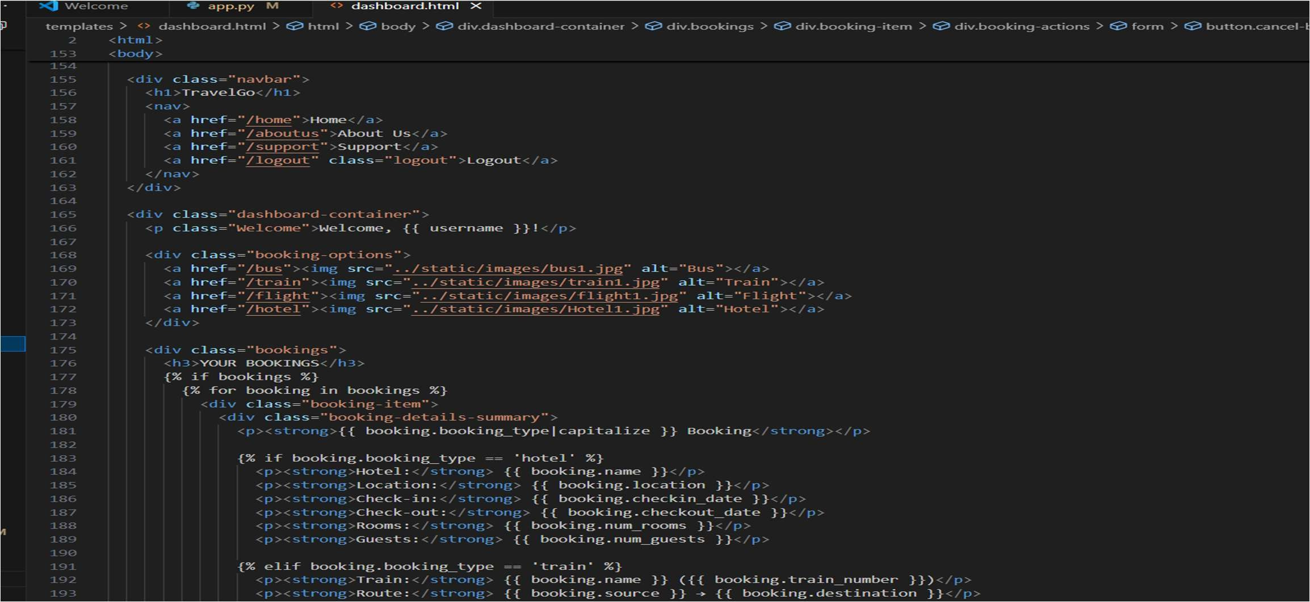

Dashboard page:

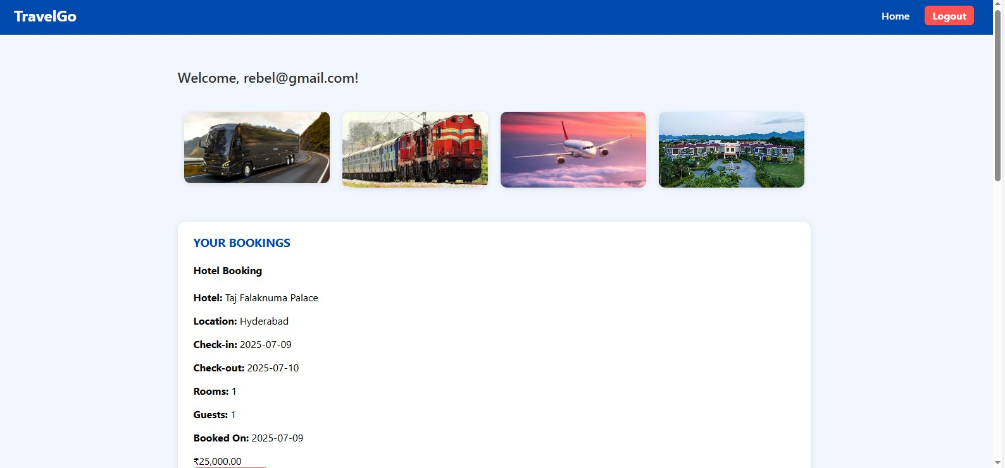

Bus Booking code:

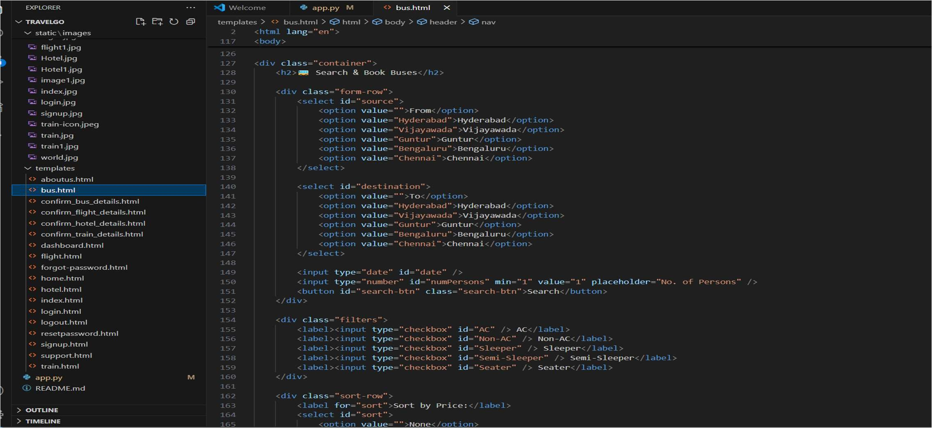

Bus booking page:

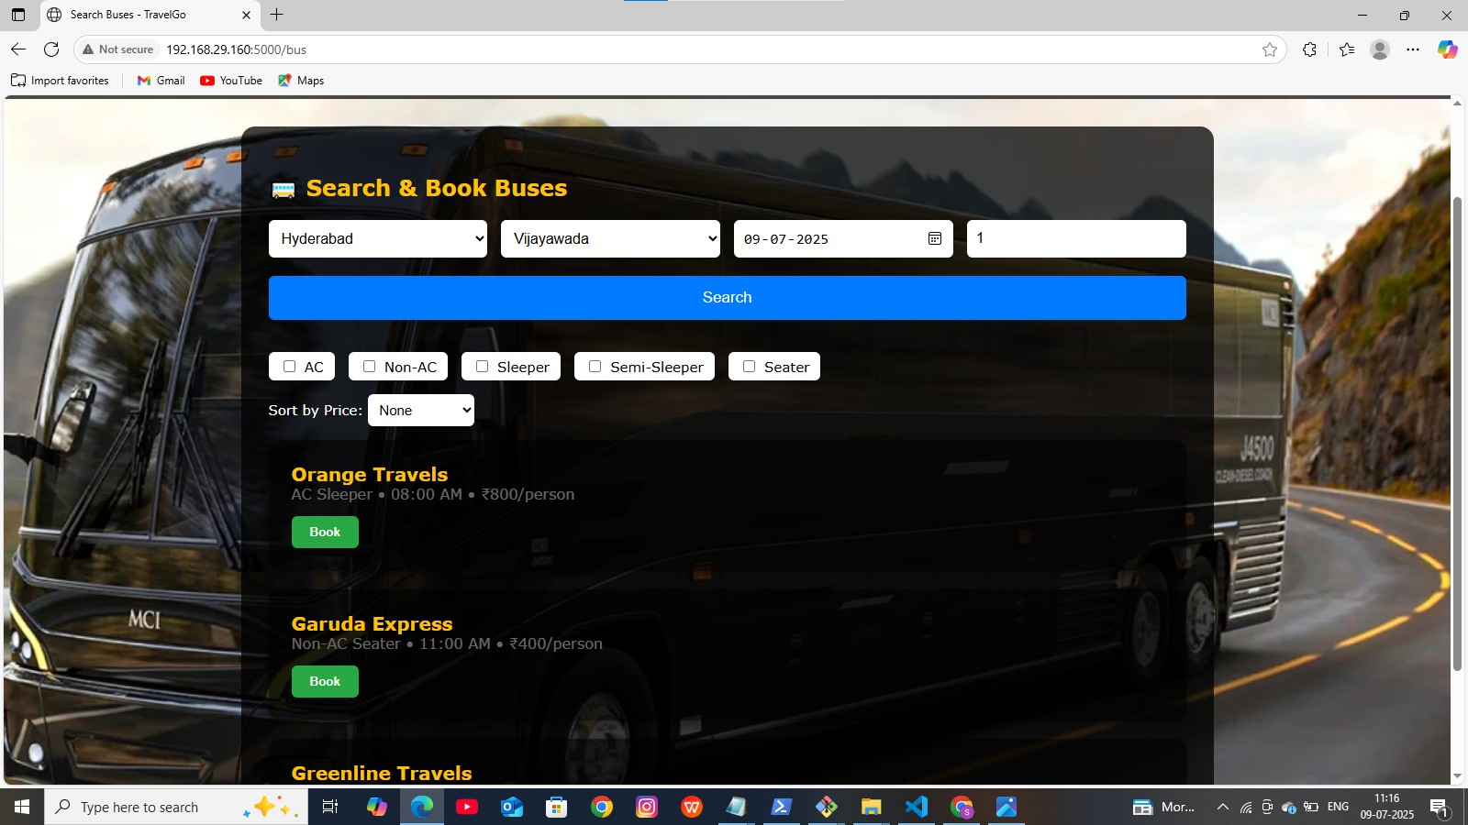

Bus Confirm Booking code:

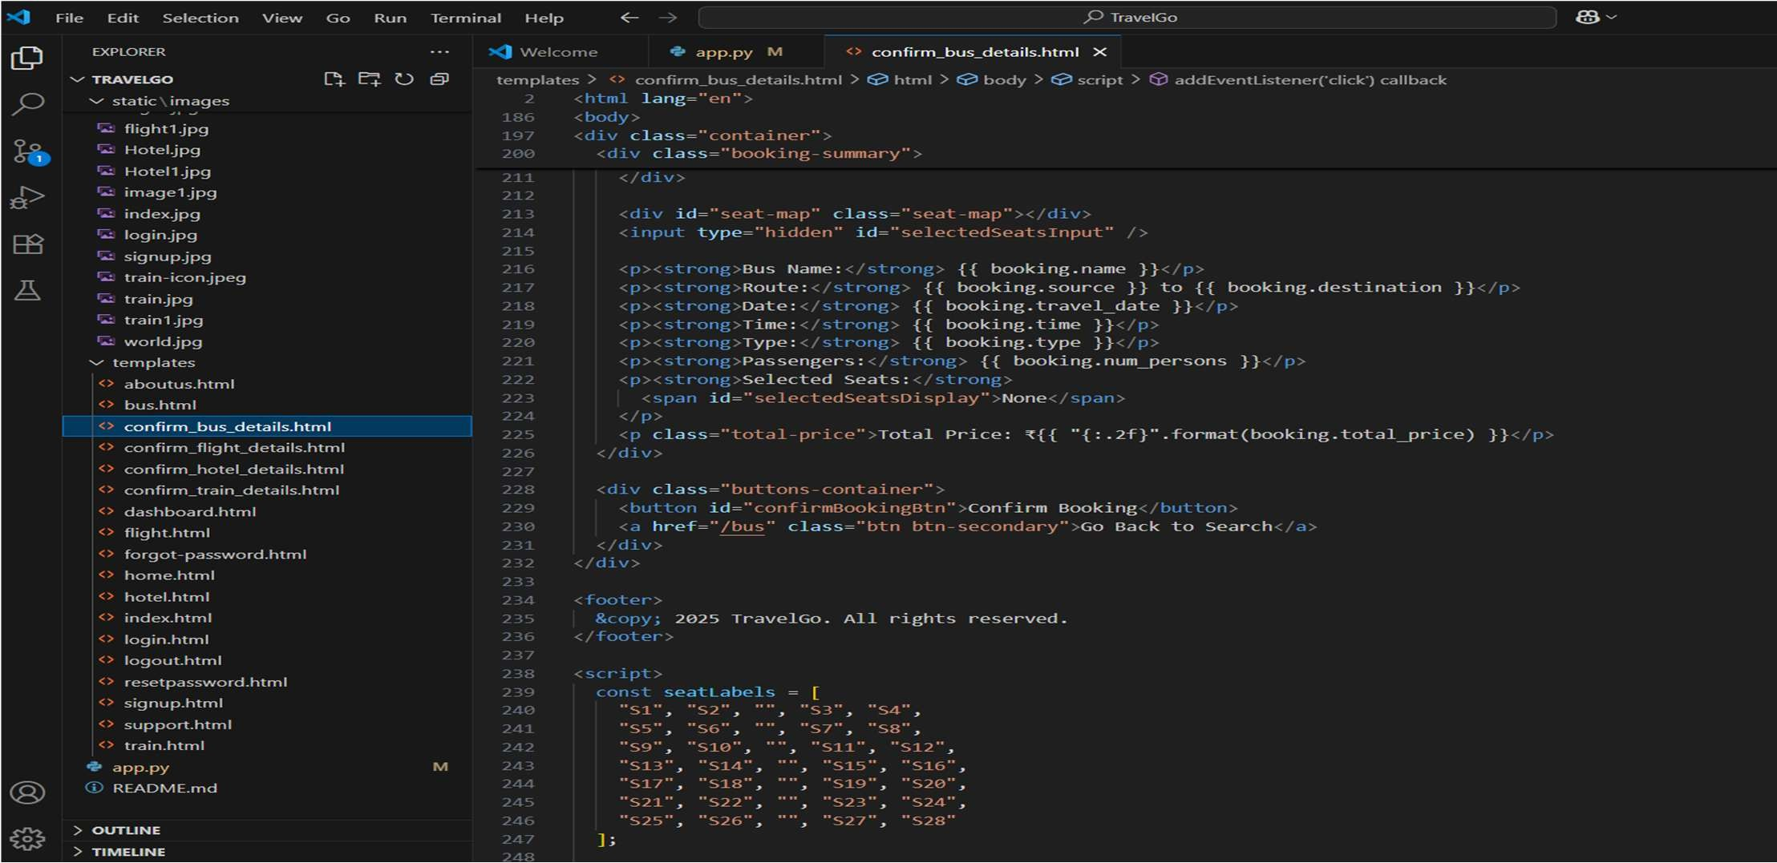

Bus confirm booking page:

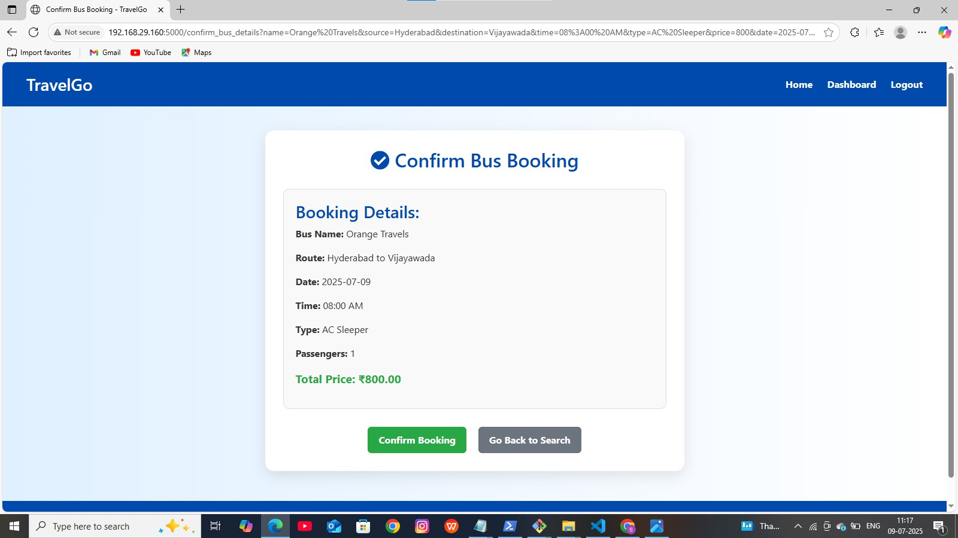

Train code :

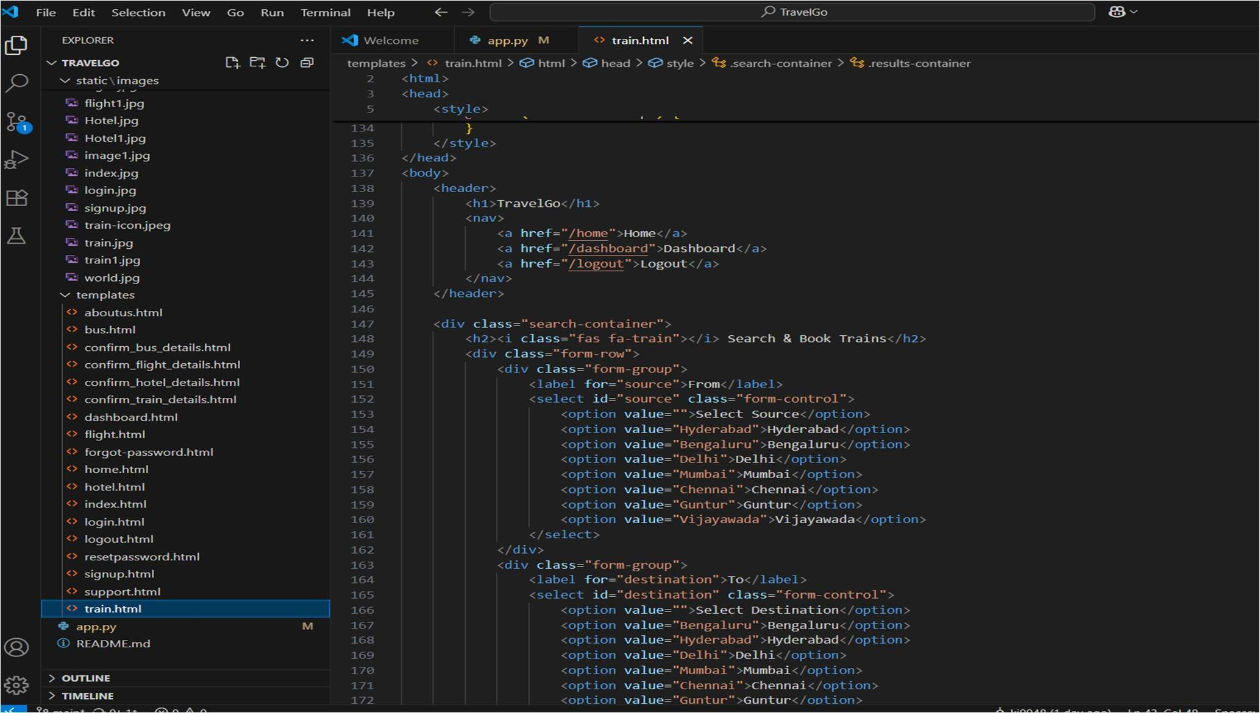

Train booking page:

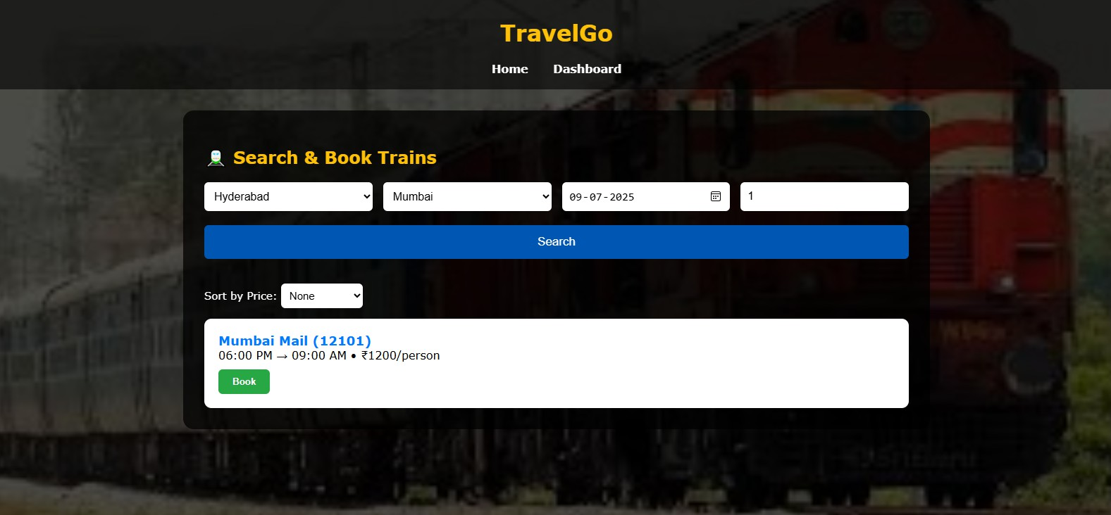

Train confirm booking code:

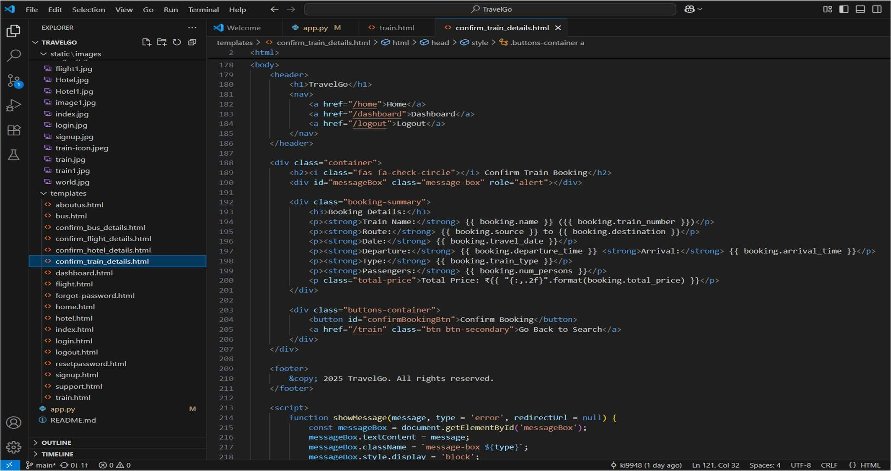

Train confirm booking page:

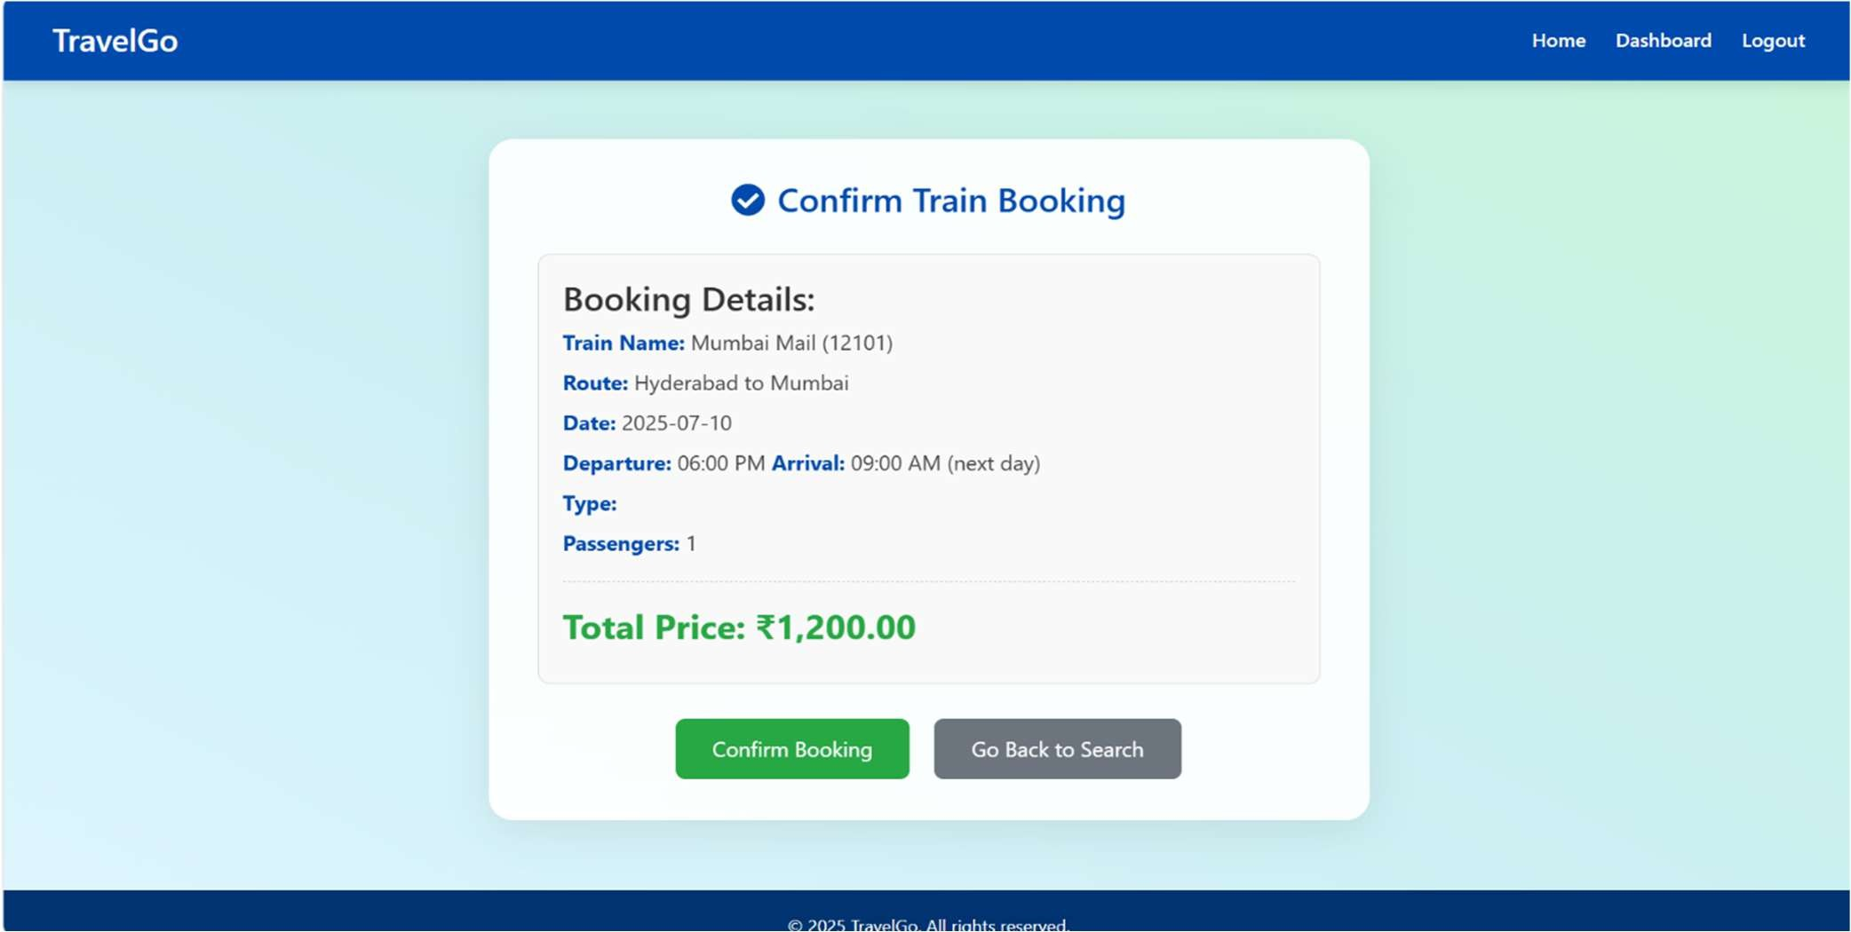

Flight code:

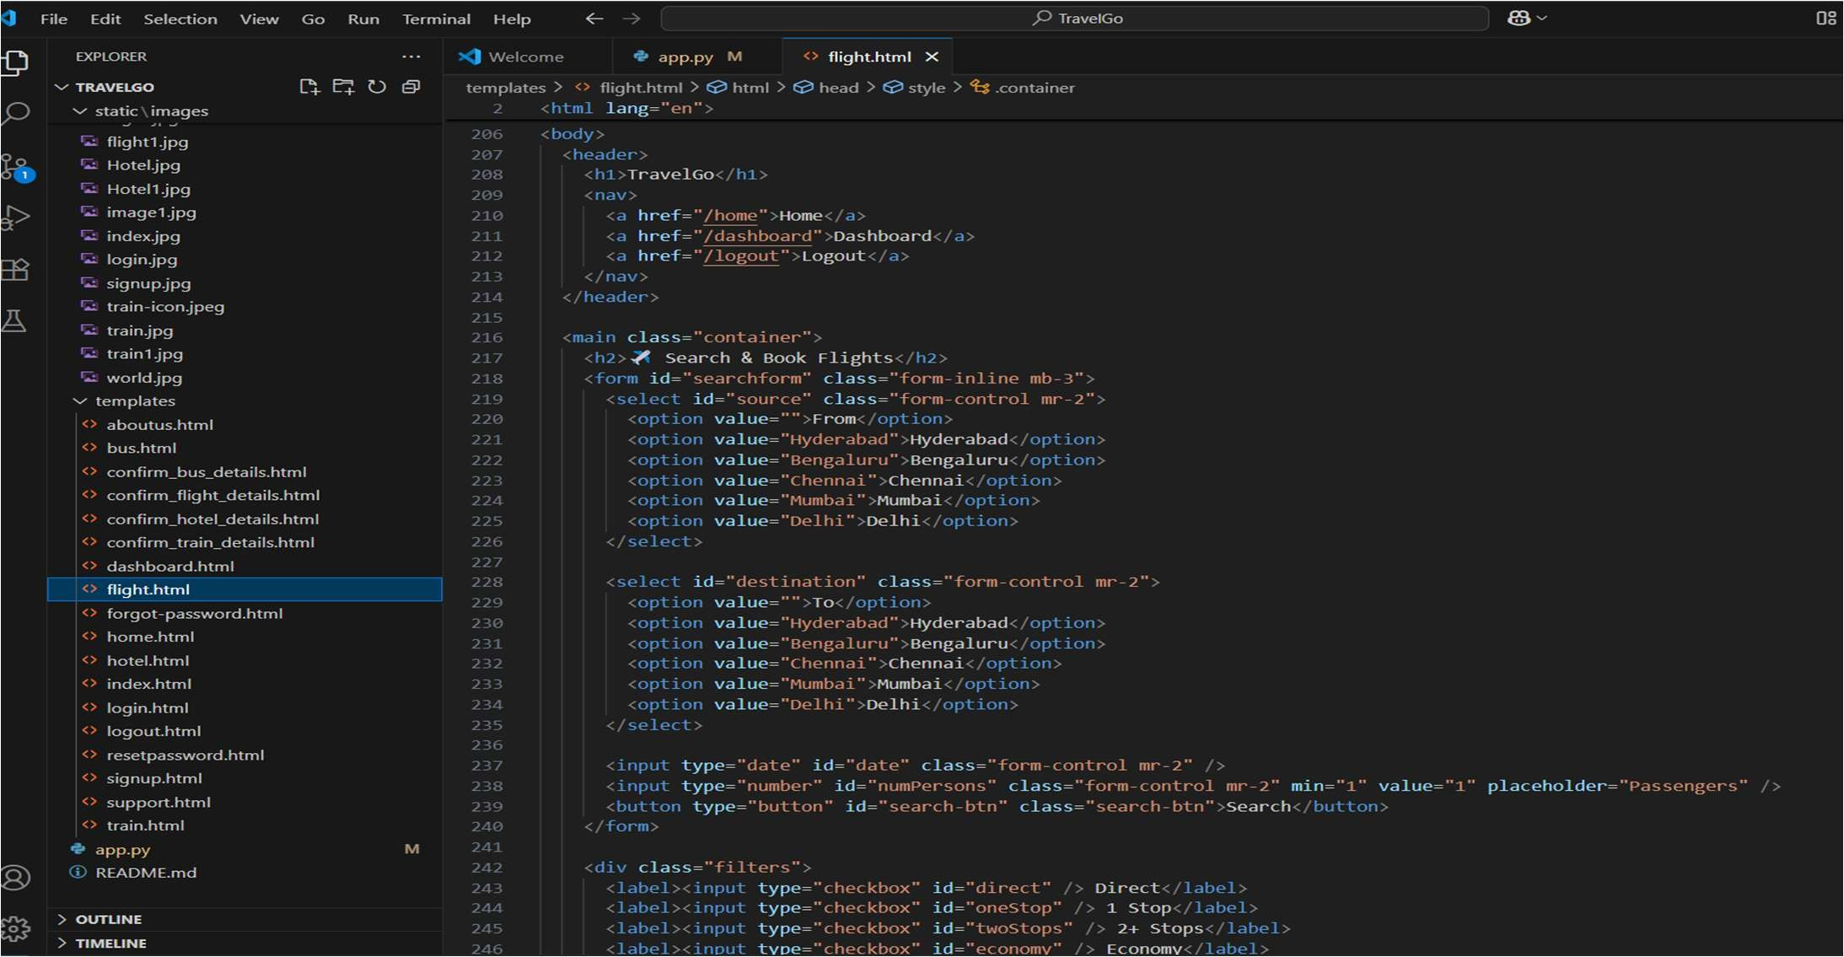

Flight page:

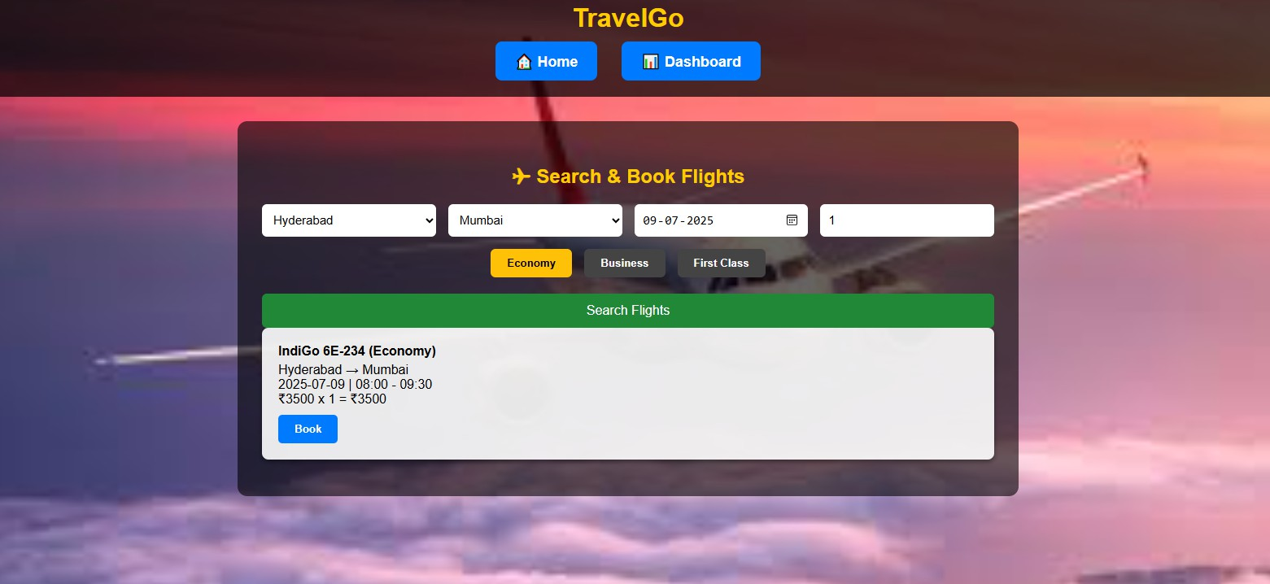

Flight confirm booking code:

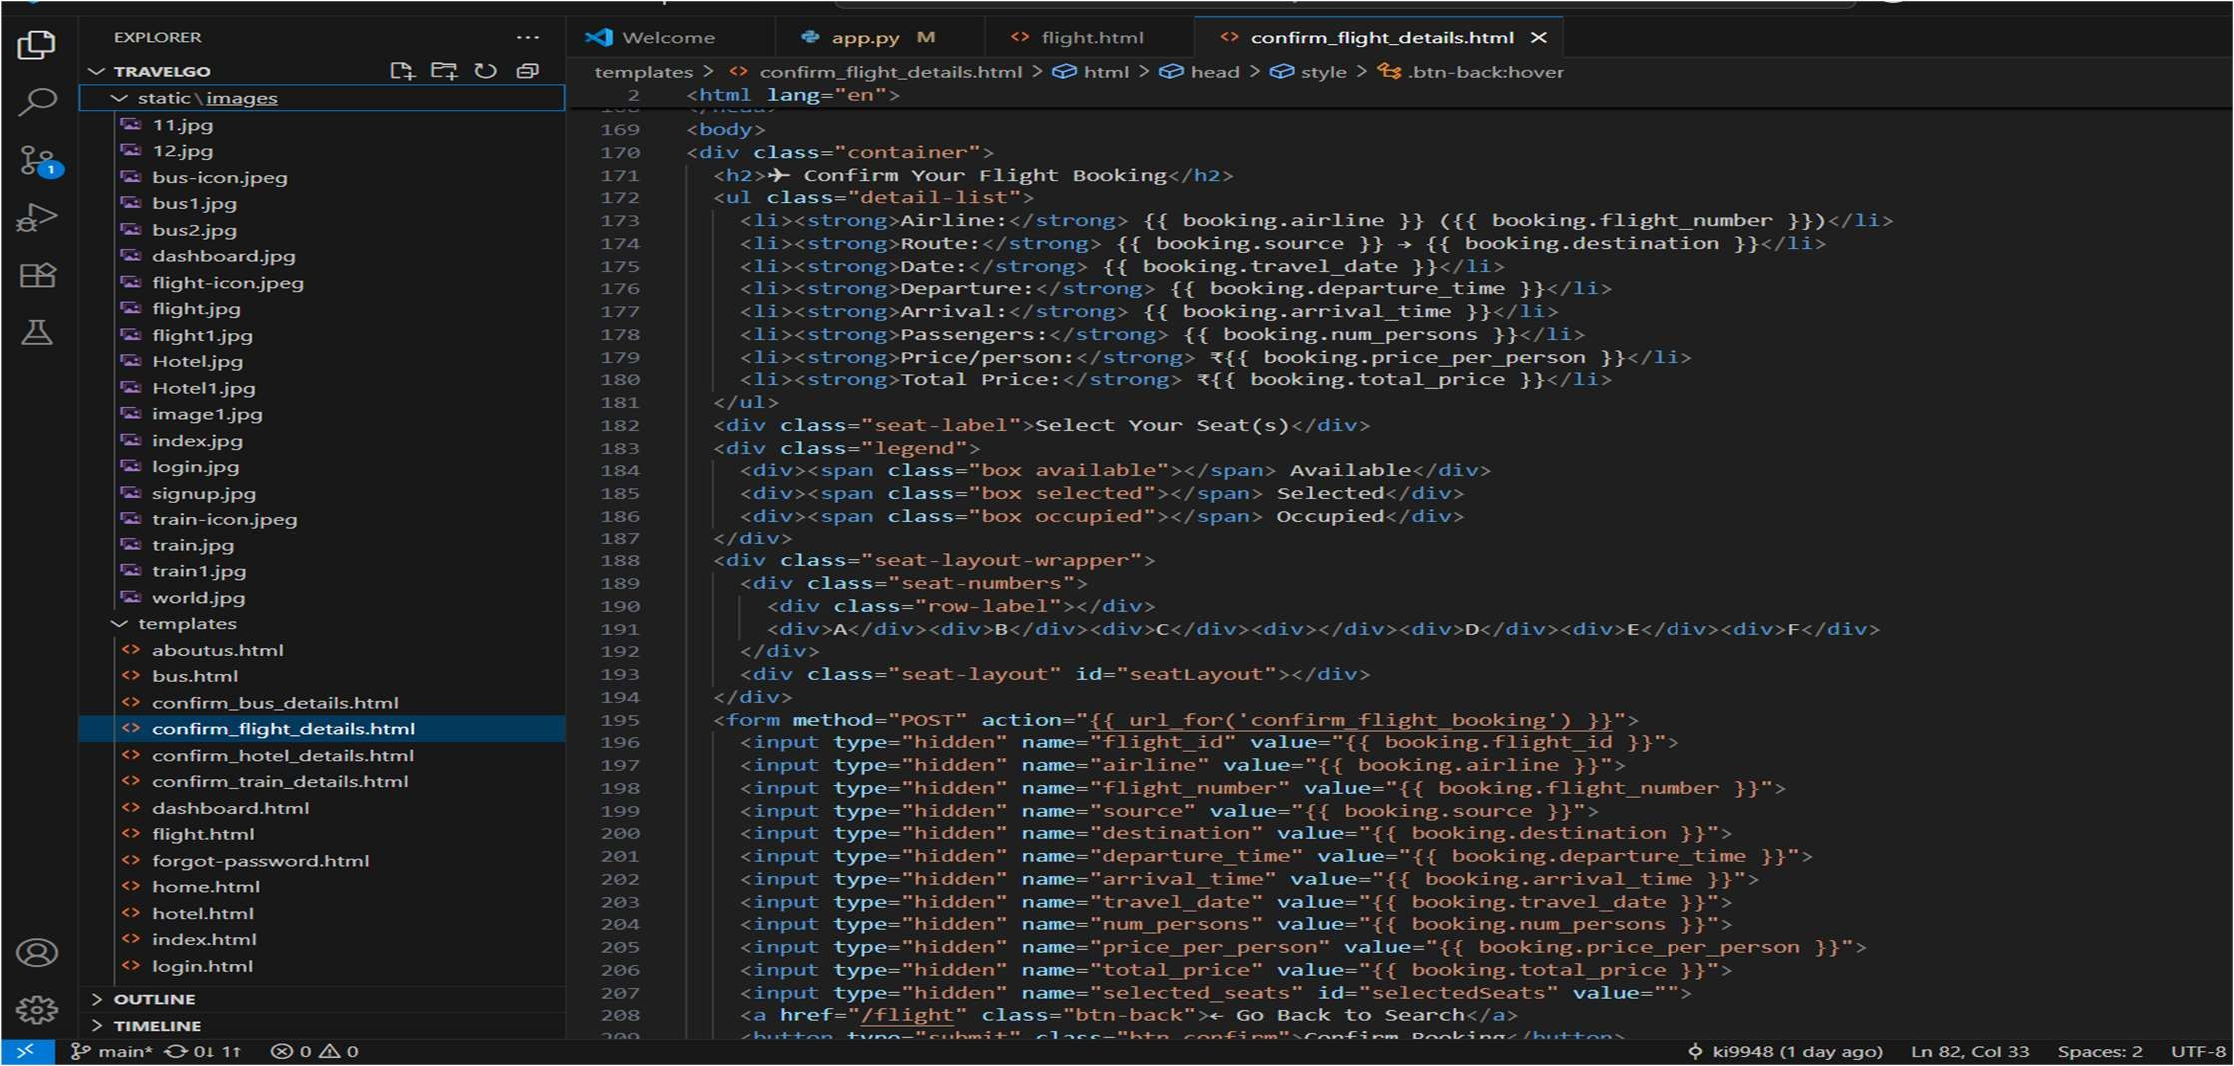

Flight confirm booking page:

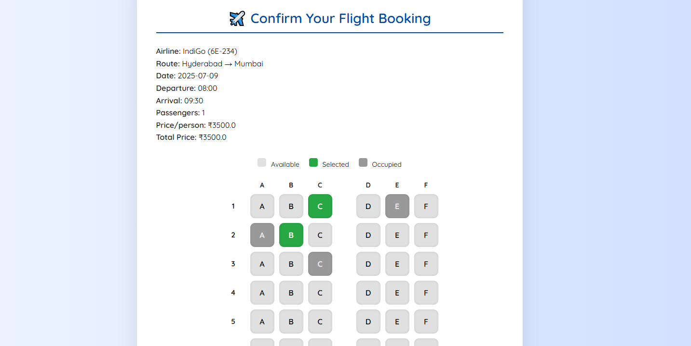

Hotel code:

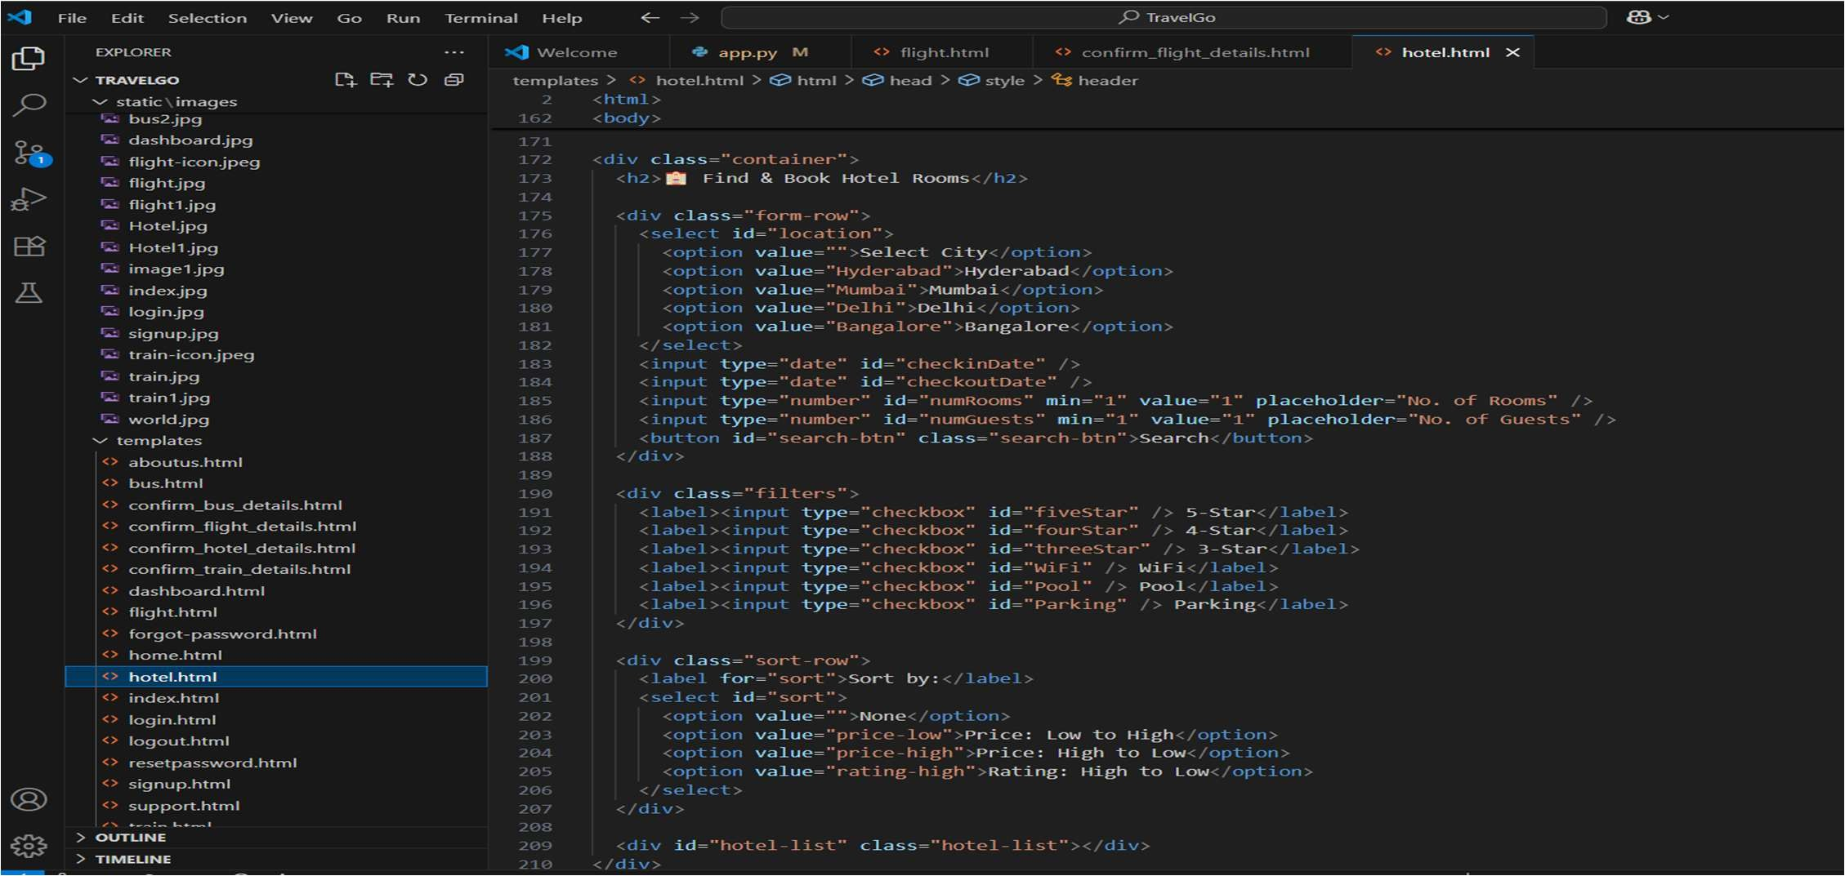

Hotel page:

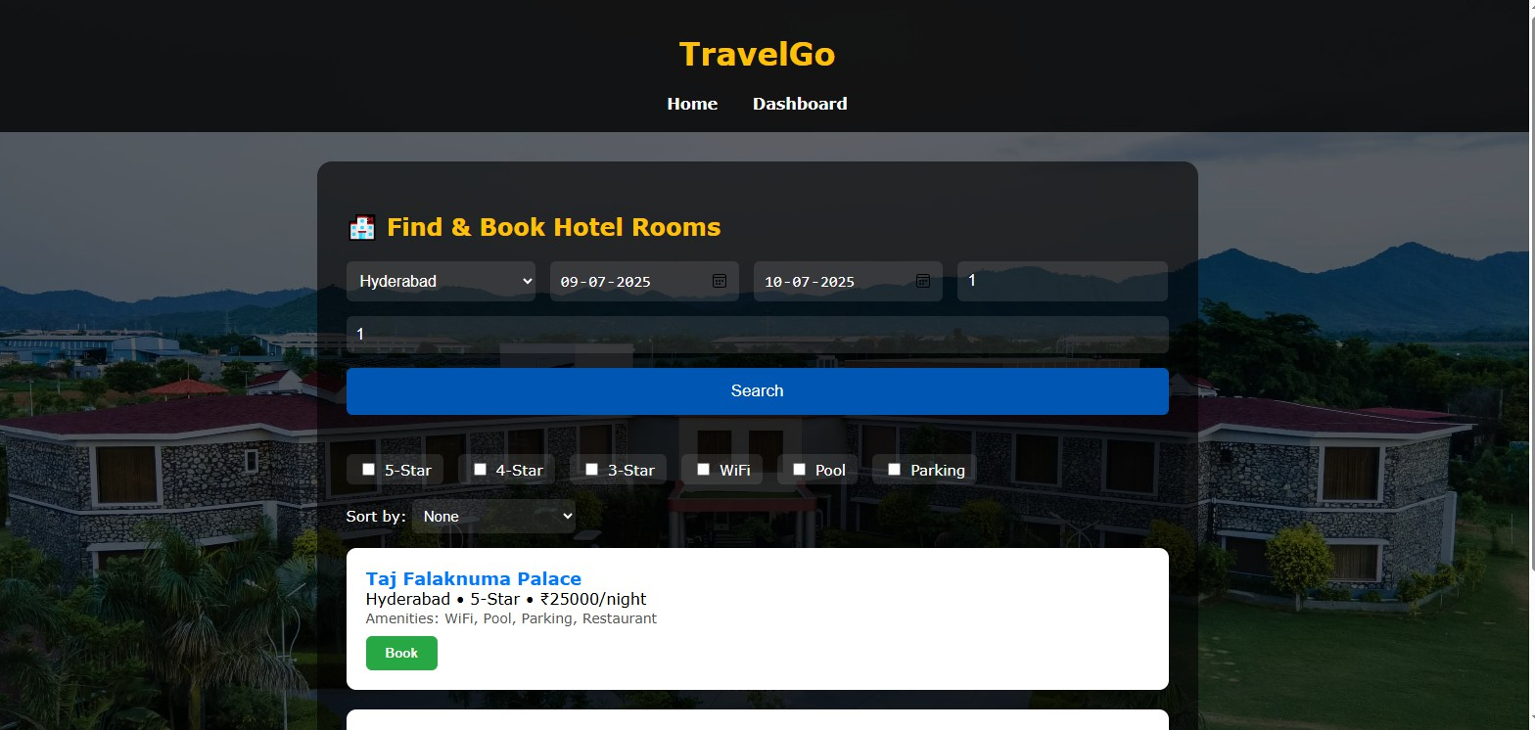

Hotel confirm booking code:

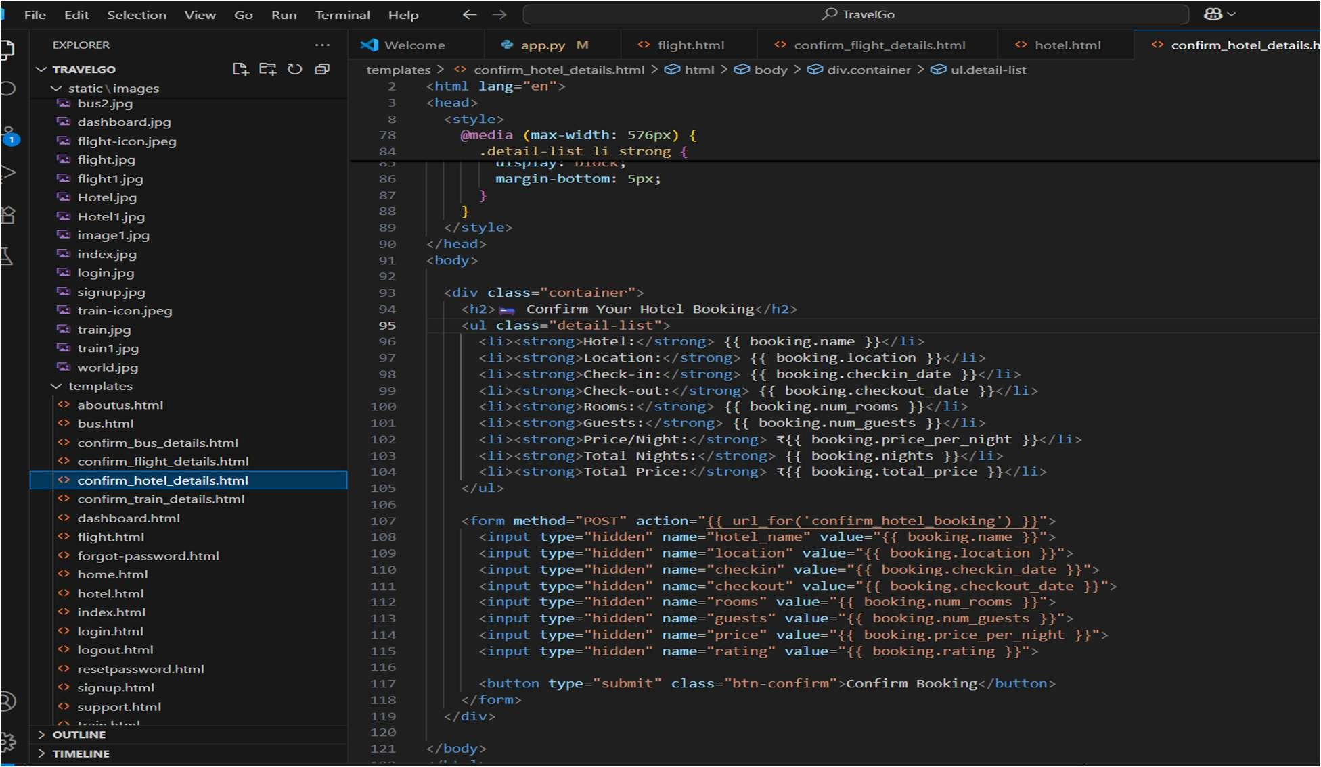

Hotel confirm booking page:

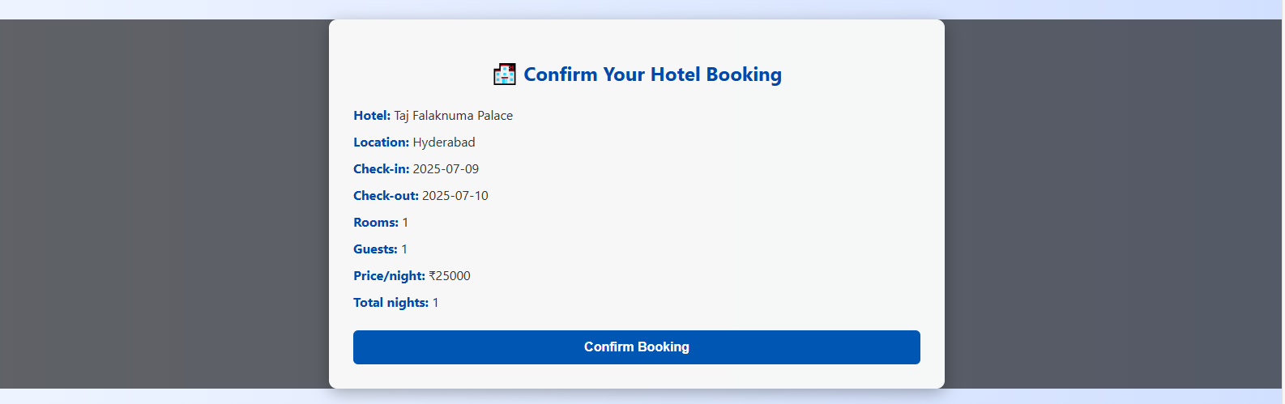

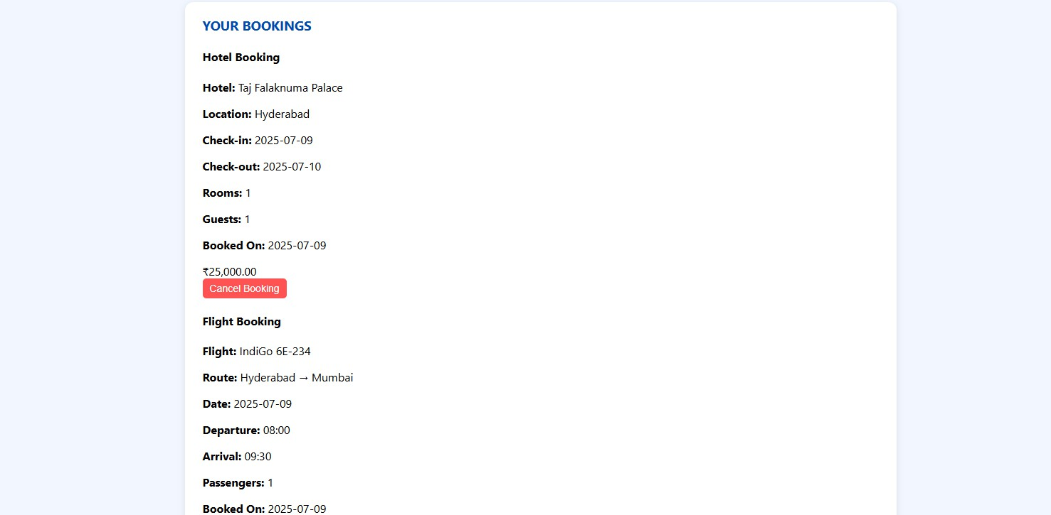Bookings page:

Cancel booking page:

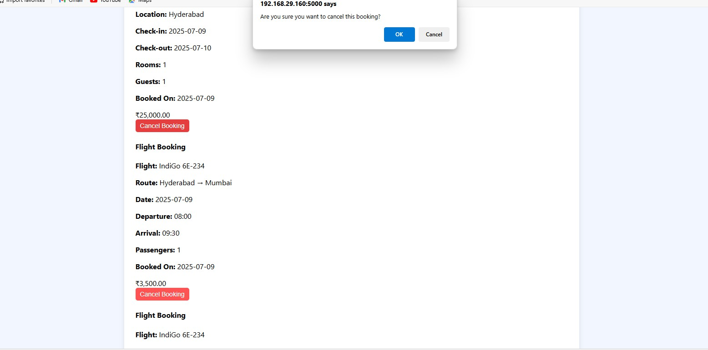

**Conclusion:**

The **TravelGo** Website has been successfully developed and deployed using a scalable and cloud-native architecture. Leveraging AWS services such as EC2 for hosting, DynamoDB for real-

time data management, and SNS for instant booking and cancellation notifications, the platform provides a seamless travel booking experience for users. TravelGo enables registered users to search and book buses, trains, flights, and hotels in a centralized, intuitive interface, eliminating the complexities of navigating multiple travel services.

The cloud infrastructure ensures high availability and smooth performance even during peak usage, while the Flask backend ensures efficient handling of user authentication, dynamic booking flows, and data transactions. Real-time notification integration via AWS SNS allows users to receive booking confirmations and cancellations immediately via email, improving communication and user engagement.

In summary, the **TravelGo** Website offers a modern, reliable, and user-friendly solution for managing travel and accommodation needs. It highlights the potential of cloud-based platforms in building unified travel systems, simplifying operations, and enhancing the overall user experience.